MOI UNIVERSITY
SCHOOL OF INFORMATION SCIENCES
DEPARTMENT OF INFORMATION TECHNOLOGY

A CONTEXT-AWARE MACHINE LEARNING BASED MODEL FOR ICT HELP DESK TICKETS MANAGEMENT: A CASE STUDY OF MOI UNIVERSITY

BY
ELIUD TUWEI
MSC/IT/04/2015

A Thesis Submitted to the School of Information Sciences in Partial Fulfilment of the Requirements for the Award of the Degree of Master of Science in Information Technology, Moi University

Supervisors:
Dr. Irene Moseti
Dr. Joram Mutai

2026

DECLARATION

Declaration by the Candidate
This thesis is my original work and has not been presented for the award of a degree in any other university. No part of this thesis may be reproduced without the prior written permission of the author and/or Moi University.

Signature: ______________________________ Date: ______________________
Eliud Tuwei
MSC/IT/

Declaration by the Supervisors
This thesis has been submitted for examination with our approval as University Supervisors.

Signature: ______________________________ Date: ______________________
Dr. Irene Moseti
Department of Information Technology, Moi University

Signature: ______________________________ Date: ______________________
Dr. Joram Mutai
Department of Information Technology, Moi University

DEDICATION

This work is dedicated to my family, for their patience, encouragement and unwavering support throughout the course of this study.

ACKNOWLEDGEMENT

I am grateful to God for granting me the strength and resources to undertake this study. I sincerely thank my supervisors, Dr. Irene Moseti and Dr. Joram Mutai, for their guidance, constructive criticism and encouragement throughout the development of this thesis. I also thank the Department of Information Technology, Moi University, for the academic support extended to me during the programme. My appreciation further goes to the Moi University ICT Directorate for their cooperation in facilitating access to the resources required for this research, and to my colleagues and family for their continued encouragement.

ABSTRACT

University information and communication technology (ICT) help desks receive large volumes of unstructured text requests spanning connectivity, account management, application support, learning-management-system platforms and hardware issues. Because similar problems are frequently described in different ways, while the same terms recur across unrelated problem types, manual interpretation, categorization, resolver assignment and reuse of prior resolutions become increasingly difficult as ticket volumes grow. Although machine learning and natural language processing (NLP) techniques have been applied to IT service ticket classification in enterprise and non-Kenyan settings, there is limited validated, institution-specific evidence on how context-aware approaches perform in a Kenyan public-university ICT help desk environment, and classification, resolver routing and historical-resolution recommendation have often been studied separately rather than as an integrated decision-support problem. This study investigated the effectiveness of context-aware machine-learning and NLP approaches for the classification, resolver routing and historical-resolution recommendation of ICT help desk tickets at Moi University. The study was guided by four objectives: to identify textual, contextual and metadata features relevant to ticket classification, resolver routing and resolution recommendation; to preprocess and represent historical ticket data using appropriate NLP and feature-representation techniques; to develop and comparatively evaluate machine-learning approaches for ticket classification and resolver routing; and to evaluate semantic retrieval approaches for recommending relevant historical resolutions. The study adopted a mixed-methods approach combining quantitative model-performance evaluation with questionnaire-based evidence from ICT support personnel, within a Design Science Research design complemented by experimental comparison of alternative modelling approaches. Historical osTicket records and relevant ICT support staff at Moi University constituted the population, with the individual ticket as the primary unit of analysis. Candidate approaches span classical machine-learning classifiers (Multinomial Naïve Bayes, Logistic Regression, Linear Support Vector Machines), ensemble methods (Random Forest, XGBoost) and contextual/semantic benchmarks (transformer-based sentence encoders), evaluated using accuracy, precision, recall, F1-score, correct-routing rate and ranking-based recommendation metrics such as Top-K accuracy and Mean Reciprocal Rank. It is anticipated that the study will generate empirical evidence on which features, representations and modelling approaches are most effective for ICT help desk decision support in the study context, and that the resulting evidence-based framework will inform the design of a prototype for classification, routing and knowledge-reuse support at Moi University and comparable institutions. Chapters Four and Five report the completed analysis. A screened corpus of 4,617 tickets spanning 7 service categories and 7 resolver teams was partitioned into 3,693 training and 924 held-out records, and two modelling approaches were compared on that common partition: a single end-to-end model over one shared lexical representation, and three dedicated context-aware models built and tuned independently for each decision. Ticket classification reached macro F1 of 0.901, resolver routing 0.696, and semantic retrieval recommended a relevant historical resolution within the top five results for 93.9% of held-out queries. The two approaches performed comparably on accuracy, and differed mainly in operational properties — retraining cost, error propagation and explainability. Free-text content carried almost all of the usable signal, while structured metadata contributed marginally, and neither feature representation dominated across all three decisions. The analysis was conducted on a corpus constructed to the authorised export's field specification pending institutional data-access approval, so absolute performance levels are to be re-estimated on institutional data, while the comparative and methodological findings stand.

TABLE OF CONTENTS

DECLARATION 2
Declaration by the Candidate 2
Declaration by the Supervisors 2
DEDICATION 4
ACKNOWLEDGEMENT 5
ABSTRACT 6
LIST OF FIGURES 11
LIST OF TABLES 12
LIST OF ABBREVIATIONS AND ACRONYMS 13
DEFINITION OF KEY TERMS 14
CHAPTER ONE 15
1.1 Background of the Study 15
1.2 Statement of the Problem 16
1.3 Purpose of the Study 17
1.4 Objectives of the Study 17
1.4.1 General Objective 17
1.4.2 Specific Objectives 17
1.5 Research Questions 18
1.6 Justification of the Study 18
1.7 Significance of the Study 18
1.8 Scope of the Study 19
1.9 Limitations of the Study 19
1.10 Assumptions of the Study 20
1.11 Organization of the Thesis 20
CHAPTER TWO 22
2.1 Introduction 22
2.2 The Concept of ICT Help Desk Ticket Management 22
2.3 Rule-Based and Traditional Classification Approaches 23
2.4 Machine-Learning Approaches to Ticket Classification 23
2.5 Context-Aware NLP and Feature Representation 24
2.6 Intelligent Ticket Routing 25
2.7 Semantic Retrieval and Historical-Resolution Recommendation 26
2.8 Empirical Studies in Institutional and University Contexts 26
2.9 Theoretical Framework 27
2.10 Conceptual Framework 29
2.11 Chapter Summary and Research Gap 30
CHAPTER THREE 31
3.1 Introduction 31
3.2 Research Approach and Philosophy 31
3.3 Research Design 31
3.4 Study Area 33
3.5 Target Population 33
3.6 Sampling Frame, Sample Size and Sampling Technique 34
3.6.1 Tickets 34
3.6.2 ICT Support Staff 34
3.7 Unit of Analysis and Data Sources 34
3.8 Data Collection Instruments 35
3.8.1 Historical Data Extraction Template 35
3.8.2 Questionnaire 35
3.8.3 Document Review Guide 35
3.9 Piloting of Instruments 35
3.10 Validity and Reliability 36
3.11 Data Processing and Feature Representation 36
3.12 Candidate Models 37
3.13 Tools and Technologies 37
3.14 Model Evaluation Metrics 38
3.15 Data Analysis Procedure 38
3.16 Ethical Considerations 38
3.17 Chapter Summary 39
CHAPTER FOUR 40
4.1 Introduction 40
4.2 Ticket Dataset and Respondent Profile 40
4.3 Feature Identification (Objective One / RQ1) 40
4.4 Data Preprocessing and Feature-Representation Results (Objective Two / RQ2) 40
4.5 Comparative Evaluation of Classification and Resolver-Routing Models (Objective Three / RQ3) 40
4.6 Evaluation of Historical-Resolution Recommendation (Objective Four / RQ4) 41
4.7 Discussion of Findings 41
4.8 Chapter Summary 41
CHAPTER FIVE 42
5.1 Introduction 42
5.2 Summary of Findings 42
5.3 Conclusion 42
5.4 Recommendations 42
5.4.1 Recommendations for Practice 42
5.4.2 Recommendations for Further Research 42
REFERENCES 43
APPENDICES 45
Appendix I: Introductory Letter (Placeholder) 46
Appendix II: Data Extraction Template (Structure) 47
Appendix III: Questionnaire for ICT Support Personnel (Draft) 48
Appendix IV: Indicative Work Plan 49

LIST OF FIGURES

Figure 2.1: Theoretical Framework combining Supervised Learning Theory, Semantic Similarity/Information Retrieval and Design Science Research
Figure 2.2: Conceptual Framework of the Study
Figure 3.1: Design Science Research Process Adopted for the Study (adapted from Peffers et al., 2008)
Figure 3.2: Research Sequence
Figure 3.3: Data Processing and Feature-Representation Pipeline
Figure 4.1: Class Distribution after Screening
Figure 4.2: Cumulative Contribution of Each Context Block
Figure 4.3: Contextual versus Lexical Representation
Figure 4.4: Arm A — The End-to-End Model and its Individual Branches
Figure 4.5: End-to-End versus Task-Specific Models
Figure 4.6: Routing Confusion Matrices
Figure 4.7: Historical-Resolution Recommendation

LIST OF TABLES

Table 3.1: Summary of Data Sources and Fields
Table 3.2: Candidate Machine-Learning and Semantic-Retrieval Models
Table 3.3: Evaluation Metrics by Research Objective
Table 4.1: Data-Quality Screening Audit
Table 4.2: Class Distribution after Screening
Table 4.3: Cumulative Contribution of Each Context Block
Table 4.4: Contextual versus Lexical Representation
Table 4.5: Arm A — The End-to-End Model and its Individual Branches
Table 4.6: Arm B Classifier-Head Selection
Table 4.7: Arm B — Dedicated Context-Aware Models
Table 4.8: Arm A versus Arm B, Held-Out Test Set
Table 4.9: Paired Significance Tests (McNemar, Exact)
Table 4.10: Combining Gain in Arm A
Table 4.11: Per-Class Routing Performance, Arm A
Table 4.12: Per-Class Routing Performance, Arm B
Table 4.13: Arm B Recommendation Variants
Table 4.14: Arm A — Historical-Resolution Recommendation
Table 4.15: Arm B — Historical-Resolution Recommendation
Table 4.16: Operational Comparison of the Two Arms

LIST OF ABBREVIATIONS AND ACRONYMS

Abbreviation | Meaning
DSR | Design Science Research
DSRM | Design Science Research Methodology
F1 | F1-score (harmonic mean of precision and recall)
ICT | Information and Communication Technology
IR | Information Retrieval
IT | Information Technology
ITSM | IT Service Management
LMS | Learning Management System
ML | Machine Learning
MRR | Mean Reciprocal Rank
NLP | Natural Language Processing
RQ | Research Question
SVM | Support Vector Machine
TF-IDF | Term Frequency–Inverse Document Frequency
XGBoost | Extreme Gradient Boosting

DEFINITION OF KEY TERMS

Context-aware model: A model whose predictions take into account surrounding textual, categorical or historical information about a ticket, rather than relying on isolated keyword matches.
Ticket classification: The assignment of an incoming help desk ticket to a predefined category or service type.
Resolver routing: The assignment of a classified ticket to the appropriate individual, team or unit responsible for resolving it.
Historical-resolution recommendation: The retrieval and ranking of previously resolved tickets that are semantically similar to a new ticket, for the purpose of reusing prior solutions.
Semantic retrieval: An information-retrieval approach that ranks or matches text based on meaning rather than exact keyword overlap, typically using vector embeddings.

CHAPTER ONE
INTRODUCTION

1.1 Background of the Study
Information and Communication Technology (ICT) services underpin teaching, learning, research and administration in contemporary universities. Learning management systems, email and collaboration platforms, network connectivity, administrative information systems and end-user computing devices are all mediated by ICT infrastructure that must remain available and supported. Consequently, university ICT help desks function as the primary interface between ICT service providers and the staff, students and administrators who depend on these services, and they receive a continuous and often high volume of support requests, commonly referred to as tickets, covering issues such as network connectivity, account and access management, application errors, learning-management-system platform problems and hardware faults.
A substantial proportion of the information contained in help desk tickets is unstructured free text produced by users with varying technical vocabulary and levels of descriptive precision. Different users frequently describe the same underlying problem using different words, while the same terms may appear in tickets that in fact relate to unrelated problem categories. This variability complicates the tasks of interpreting, categorizing and routing tickets to the appropriate resolver, and it can obscure opportunities to reuse previously documented resolutions for recurring or related problems. As ticket volumes increase, the effort required for manual triage, categorization and routing grows correspondingly, creating pressure on ICT support capacity and increasing the risk of misclassification, incorrect assignment, and subsequent ticket reassignment.
Historical ticket records held within help desk platforms, such as osTicket, represent an accumulated body of institutional knowledge: prior problem descriptions paired with the categories, resolvers and resolutions ultimately applied to them. In principle, this historical record could be systematically exploited to support the classification of new tickets, the routing of tickets to appropriate resolvers, and the recommendation of previously successful resolutions for semantically similar new tickets. However, whether and how such reuse can be operationalized effectively depends on the extent to which contextual and semantic information, rather than surface keyword matching alone, can be captured through natural language processing (NLP) and machine learning (ML) techniques.
Machine learning and NLP approaches to IT service ticket classification, routing and recommendation have received growing research attention, ranging from classical supervised classifiers using bag-of-words or TF-IDF representations to more recent contextual and transformer-based semantic representations. Nevertheless, much of the reported evidence originates from enterprise or non-Kenyan institutional settings whose ticket vocabularies, categorical structures and organizational routing patterns differ from those of a Kenyan public university. This study is therefore situated within the Moi University ICT help desk context, and investigates whether and how context-aware machine-learning and NLP approaches can support ticket classification, resolver routing and historical-resolution recommendation in that specific institutional setting.

1.2 Statement of the Problem
The core problem addressed by this study is the lack of validated, institution-specific evidence on how context-aware machine-learning approaches can support ICT help desk ticket classification, resolver routing and historical-resolution recommendation at Moi University. Several interrelated challenges motivate this problem statement. First, increasing ticket volumes raise the manual effort required for interpretation and categorization, creating a scalability challenge for ICT support teams. Second, help desk tickets are predominantly unstructured text containing abbreviations, spelling variation and ambiguous descriptions, which complicates consistent classification. Third, purely keyword-based matching approaches may fail to distinguish tickets that share vocabulary but differ substantially in underlying intent, limiting classification accuracy where terminology overlaps across categories. Fourth, misclassification at the point of ticket intake can lead to incorrect resolver assignment and subsequent reassignment, delaying resolution and increasing operational overhead. Fifth, historical resolutions accumulated within the help desk system may contain solutions directly applicable to new, similar tickets, yet these resolutions are not always systematically surfaced or reused, representing an underexploited knowledge asset.
Without empirical, institution-specific evidence on which textual, contextual and metadata features, preprocessing techniques and modelling approaches are most effective in this environment, Moi University's ICT help desk operations continue to rely on manual or ad hoc practices that may not scale efficiently with growing service demand. This study addresses that gap by generating such evidence within the Moi University context.

1.3 Purpose of the Study
The purpose of this study is to investigate the effectiveness of context-aware machine-learning and NLP approaches for the classification, resolver routing and historical-resolution recommendation of ICT help desk tickets at Moi University.

1.4 Objectives of the Study

1.4.1 General Objective
To investigate the effectiveness of context-aware machine-learning and NLP approaches for classification, resolver routing and historical-resolution recommendation of ICT help desk tickets at Moi University.

1.4.2 Specific Objectives
- To identify textual, contextual and metadata features relevant to ticket classification, resolver routing and resolution recommendation.
- To preprocess and represent historical ICT help desk ticket data using appropriate NLP and feature-representation techniques.
- To develop and comparatively evaluate machine-learning approaches for ticket classification and resolver routing, comparing task-specific models trained independently for each task against a single integrated model that performs both tasks from a shared representation.
- To evaluate semantic retrieval approaches for recommending relevant historical resolutions and determine how the findings can inform a prototype workflow.

1.5 Research Questions
- What textual, contextual and metadata features are relevant to ICT help desk ticket classification, resolver routing and resolution recommendation?
- Which data preprocessing and feature-representation techniques are suitable for context-aware modelling of ICT help desk tickets?
- How do alternative machine-learning approaches compare in the classification and resolver routing of ICT help desk tickets, and how does a single integrated model compare with task-specific models trained independently for each task?
- How effectively can semantic retrieval approaches recommend relevant historical resolutions for new ICT help desk tickets?

1.6 Justification of the Study
This study is justified on academic, methodological, institutional and practical grounds. Academically, it generates empirical evidence on context-aware NLP, machine learning and semantic retrieval within a Kenyan public-university ICT service environment, an institutional setting that is under-represented in the existing literature relative to enterprise and non-Kenyan contexts. Methodologically, the study provides a structured comparison of alternative feature representations and machine-learning approaches rather than assuming a priori that a single algorithm is universally superior, consistent with recommended practice in comparative ITSM ticket-classification research. Institutionally, the study uses the Moi University ICT help desk context to identify evidence relevant to local ticket categories, terminology and resolver patterns, which enterprise-derived findings cannot be assumed to generalize to directly. Practically, the findings may inform decision support for faster triage, routing and reuse of prior resolutions, thereby supporting more efficient ICT service delivery. The immediate contribution of the study is knowledge: evidence about which features, representations and models perform best in the study context. A prototype is treated as an eventual artefact potentially informed by these findings, rather than the starting assumption of the research.

1.7 Significance of the Study
The findings of this study are expected to be of value to several groups of stakeholders.
- Moi University ICT Management: The study provides evidence to support ICT service-management and knowledge-reuse decisions, including possible investment in automated decision-support tools.
- ICT Support Staff: The study may point toward a potential reduction in repetitive triage effort and easier access to relevant historical cases during ticket resolution.
- Students and Staff: End users of ICT services stand to benefit from potentially more consistent ticket assignment and more timely support.
- Researchers: The study contributes empirical evidence from a Kenyan public-university ICT help desk context, extending the geographic and institutional coverage of the ITSM ticket-classification literature.
- Future Studies: The study provides a foundation for extending research to other intelligent service-management tasks beyond ICT help desks, such as facilities or academic-administration service management.

1.8 Scope of the Study
The study is conducted within the Moi University ICT help desk environment. The primary data sources are authorized historical osTicket ticket records and relevant ICT support personnel, with the individual ICT help desk ticket constituting the unit of analysis. The research scope covers textual, contextual and metadata feature identification; ticket preprocessing and representation; classification and resolver-routing evaluation; historical-resolution retrieval evaluation; comparative model assessment; and questionnaire-based staff perspectives where applicable.
The study is bounded to ICT help desk decision support and explicitly excludes autonomous ticket resolution, general-purpose chatbot development, voice processing, service-level-agreement (SLA) breach prediction, and replacement of osTicket's primary functions as the institution's ticketing system of record.

1.9 Limitations of the Study
As with most institution-specific ITSM studies, several limitations are anticipated. The findings are derived from a single institutional context and historical dataset, and generalization to other universities or organizations should therefore be made cautiously given differing ticket taxonomies and support structures. The quality and completeness of historical ticket records, including free-text descriptions and resolution notes, may vary and could constrain feature extraction and label reliability; data-quality screening procedures, described in Chapter Three, are applied to mitigate this. Where dataset size is limited, the evaluation of resource-intensive contextual/transformer representations may be constrained relative to classical machine-learning baselines. Access to historical data and staff participation is also contingent on institutional authorization, which determines the final scope and timing of data collection.

1.10 Assumptions of the Study
- Historical ticket records in the osTicket system contain sufficient volume and label consistency to support supervised model training and evaluation.
- ICT support personnel invited to participate will respond candidly to the questionnaire and document review components.
- Institutional authorization to access historical ticket data and engage relevant staff will be granted in a timeframe that allows the study to proceed as planned.

1.11 Organization of the Thesis
This thesis is organized into five chapters. Chapter One introduces the study, presenting the background, problem statement, objectives, research questions, justification, significance, scope, limitations and assumptions. Chapter Two reviews related literature on rule-based and machine-learning approaches to ticket classification, context-aware NLP, intelligent routing and semantic retrieval for resolution recommendation, and presents the theoretical and conceptual frameworks guiding the study. Chapter Three presents the research methodology, covering the research design, study population and sampling, data collection instruments, data processing and feature-representation procedures, candidate models, evaluation metrics and ethical considerations. Chapter Four, to be completed following data collection, will present the data analysis, findings and interpretation in relation to each research objective. Chapter Five, also to be completed following data collection and analysis, will present the summary of findings, conclusions and recommendations, including recommendations for further research.

CHAPTER TWO
LITERATURE REVIEW

2.1 Introduction
This chapter reviews literature relevant to context-aware machine-learning and NLP approaches for ICT help desk ticket management. The review is organized thematically, beginning with the general concept of ICT help desk ticket management, followed by rule-based approaches, machine-learning approaches to classification, context-aware NLP and feature representation, intelligent ticket routing, and semantic retrieval for historical-resolution recommendation. The chapter then presents the theoretical framework underpinning the study, the conceptual framework guiding the empirical investigation, and concludes with a synthesis identifying the specific research gap that this study addresses.

2.2 The Concept of ICT Help Desk Ticket Management
An ICT help desk, or IT service desk, functions as the primary point of contact between an organization's ICT function and the users who depend on its services, coordinating the logging, categorization, assignment and resolution of user-reported incidents and requests. In IT service management (ITSM) terms, each user-reported issue is logged as a ticket comprising, at minimum, a subject or short description, a free-text narrative of the problem, and metadata such as the reporting user, timestamps and, once resolved, a resolution note. Al-Hawari and Barham (2021) describe a help desk system in which an accurate ticket-classification model associates each ticket with its correct service category from the point of intake, arguing that this reduces resolution time, conserves support-staff effort and improves user satisfaction relative to manual categorization. Because ticket text is produced by end users rather than trained support staff, help desk ticket corpora are typically noisier, more variable in vocabulary and more inconsistently labelled than curated technical documentation, which is the central analytical challenge that context-aware ticket-management research seeks to address.

2.3 Rule-Based and Traditional Classification Approaches
Early approaches to automating ticket categorization relied on rule-based or keyword-matching systems, in which tickets are assigned to categories based on the presence of predefined keywords or patterns. Such approaches are straightforward to implement and interpret, and can perform adequately for narrow, predictable request types. However, rule-based systems are difficult to maintain as ticket vocabulary evolves and as categories begin to overlap, since each new phrasing or edge case typically requires manual rule updates. Rule-based classification also struggles to capture cases in which the same keywords appear across tickets with different underlying intent, a limitation that has motivated the shift toward statistical and machine-learning approaches capable of learning patterns directly from labelled historical data rather than relying on hand-crafted rules.

2.4 Machine-Learning Approaches to Ticket Classification
A substantial body of research has applied supervised machine-learning algorithms to IT support ticket classification. Al-Hawari and Barham (2021) developed an empirically derived methodology comprising training-ticket generation, data preprocessing, stemming, feature vectorization and machine-learning algorithm tuning to classify tickets by service category. Wibowo and Hariyanto (2023), reviewed in Harun et al.'s comparative synthesis, compared Naïve Bayes and Support Vector Machine (SVM) classifiers on a corpus of help desk tickets using standard preprocessing steps of normalization, tokenization, stop-word removal and TF-IDF vectorization; their results showed Naïve Bayes achieving higher precision but SVM achieving stronger overall accuracy and recall, illustrating the classical precision-recall trade-off across ticket categories. In a related comparative study, Prihandono et al. (2023) evaluated a wider range of classical and deep-learning algorithms, including Random Forest, SVM, Multilayer Perceptron, Recurrent Neural Networks, Long Short-Term Memory networks and Gated Recurrent Units, for IT incident-ticket prioritization on a large ticket dataset, finding that model choice materially affects prioritization performance and that ensemble and deep architectures can outperform single classical classifiers on sufficiently large data.
Ensemble methods have also been explored specifically to improve robustness on unstructured ticket text. Combining classifiers such as logistic regression, multinomial Naïve Bayes, k-nearest neighbours and SVM through ensembling has been shown to improve classification accuracy over any single constituent classifier when applied to free-text ticket descriptions (Kumar & colleagues, as synthesized in ensemble ticket-classification literature). More recent work has extended these approaches with deep architectures: a convolutional neural network (CNN)-based classifier has been proposed specifically to address sparsity, non-linearity and hand-crafted-feature limitations associated with traditional ticket classifiers, while Tai et al. (2023) compared machine-learning techniques for predicting help-desk ticket resolution time, underscoring that ticket-level prediction tasks extend beyond category assignment to operational outcomes such as time-to-resolution. Collectively, this literature establishes that no single classical algorithm dominates across all ticket-classification settings, and that comparative, dataset-specific evaluation, as adopted in this study, is necessary to identify an appropriate approach for a given institutional ticket corpus.

2.5 Context-Aware NLP and Feature Representation
The representation used to convert ticket text into a form suitable for machine-learning models materially affects classification performance. Term Frequency–Inverse Document Frequency (TF-IDF) remains a widely used, transparent and computationally inexpensive baseline representation for sparse text classification, and continues to perform competitively in several IT-ticket studies (Ferdinand et al., 2025). However, TF-IDF and related bag-of-words representations treat words independently of context and cannot capture semantic relationships between differently worded but conceptually similar descriptions. Contextual embedding models, most notably Bidirectional Encoder Representations from Transformers (BERT) and its derivatives, address this limitation by producing dense vector representations that capture contextual meaning rather than surface word frequency. Sentence-BERT (Reimers & Gurevych, 2019) extends BERT specifically for sentence-level semantic similarity tasks using a siamese network architecture, substantially reducing the computational cost of pairwise semantic comparison while achieving strong performance on semantic textual similarity benchmarks. Comparative evaluations of information-retrieval techniques applied directly to IT support tickets have found multilingual Sentence-BERT variants to outperform traditional TF-IDF, Doc2Vec and standard BERT representations on ticket-similarity tasks, with Sentence-BERT achieving the highest proportion of relevant recommendations among eleven compared techniques (Nunes et al., as reported in recent IT-ticket information-retrieval comparisons). da Costa et al.'s (2023) survey similarly emphasizes the growing preference for deep contextual embeddings over static word embeddings such as Word2Vec for ITSM text, particularly where ticket data is noisy or multilingual. This evidence motivates the present study's design decision to evaluate both a conventional TF-IDF baseline and contextual/semantic representations comparatively, rather than assuming the superiority of either in advance.

2.6 Intelligent Ticket Routing
Ticket classification and resolver routing are related but analytically distinct tasks: correctly predicting a ticket's category does not automatically guarantee that the ticket is assigned to the correct resolver or team, since routing may depend on additional factors such as resolver workload, expertise history and organizational structure. Han et al. (2020) proposed a unified ticket-routing framework incorporating ticket-level, group-level, ticket-group and group-group features to rank candidate resolver groups, moving beyond simple category-to-team mapping. Xu and He (2018) proposed a two-stage expert-recommendation model in which unresolved tickets are progressively escalated to alternative resolvers if the initial assignment cannot resolve the issue, reflecting the iterative nature of real-world routing decisions. Automated prioritization and routing research more broadly (Harun et al., 2023) has sought to minimize misclassification-driven ticket transfer delays through machine-learning-based question classification within helpdesk ticketing-support systems. This literature supports the treatment, adopted in this study, of resolver-routing performance as a distinct dependent variable from classification accuracy, evaluated using routing-specific metrics such as correct-routing rate rather than classification accuracy alone.

2.7 Semantic Retrieval and Historical-Resolution Recommendation
A further stream of research addresses the reuse of historical ticket resolutions for new, similar tickets, generally framed as either resolution recommendation or expert recommendation (Zhou et al., 2016; Zhou et al., 2015a; Zhou et al., 2015b, as synthesized in ticket-recommendation literature). Early resolution-recommendation approaches applied k-nearest-neighbour retrieval over historical tickets to surface similar prior cases, but recognized that the same underlying problem can generate differently worded tickets over time as systems and environments change, motivating feature-adaptation techniques to preserve representation consistency. Wang et al.'s reinforcement-learning formulation cast resolution recommendation as a hierarchical multi-armed-bandit problem, recommending the resolution associated with the maximum expected reward. More recent work has shifted toward transformer-based sentence encoders for this task: comparative evaluation of eleven information-retrieval techniques on a proprietary IT-support-ticket database found that multilingual Sentence-BERT achieved the strongest performance, with approximately 78.7 percent of top recommendations judged relevant, outperforming TF-IDF, Doc2Vec and standard multilingual BERT variants (Nunes et al., in the Skaylink case study). Retrieval-augmented approaches that combine semantic embedding search with generative synthesis of resolution suggestions have also been proposed for software-issue tracking contexts, integrating Sentence-Transformer embeddings with FAISS-based approximate nearest-neighbour search to retrieve and synthesize resolution guidance from historical tickets and linked artefacts. This literature collectively supports the use of semantic-retrieval evaluation metrics, including Top-K accuracy, Precision@K, Recall@K and Mean Reciprocal Rank, as adopted in Chapter Three of this study, to assess whether semantically similar historical tickets can be reliably surfaced for new Moi University ICT help desk tickets.

2.8 Empirical Studies in Institutional and University Contexts
Several studies have specifically examined ticket classification within university or comparable institutional ICT service settings. Ferdinand et al. (2025) applied support vector machines with hyperparameter optimization to the classification of university IT help desk tickets, demonstrating that careful hyperparameter tuning materially improves classification performance on institutional ticket corpora. Jevsejev and Bereiša (2024) investigated the improvement of incident-management models using machine-learning methods within an organizational ITSM context, while Seanbudh and Siriborvornratanakul (2022) examined machine-learning-based improvements to ticket classification specifically for IT service-management systems. However, the overwhelming majority of published empirical evidence originates from enterprise organizations, or from universities and companies outside the Kenyan and East African context, whose ticket taxonomies, institutional terminology and resolver structures cannot be assumed to transfer directly to a Kenyan public university such as Moi University. This geographic and institutional concentration of existing evidence is a central motivation for the present study.

2.9 Theoretical Framework
This study is underpinned by three complementary theoretical perspectives: supervised learning theory, semantic similarity and information-retrieval theory, and Design Science Research.
Supervised Learning Theory provides the theoretical basis for learning a mapping between ticket features, whether textual, contextual or metadata-based, and known outcomes such as service category and resolver assignment, using labelled historical ticket examples. This underpins the classification and routing components of the study (Research Objectives One to Three).
Semantic Similarity and Information Retrieval theory provides the theoretical basis for representing new tickets and comparing them against previously resolved cases so that relevant historical resolutions can be ranked and retrieved, drawing on vector-space and embedding-based similarity models such as those underlying Sentence-BERT (Reimers & Gurevych, 2019). This underpins the historical-resolution recommendation component of the study (Research Objective Four).
Design Science Research (DSR), as formalized by Hevner et al. (2004) and operationalized as a process model by Peffers et al. (2008), provides the theoretical basis for producing and evaluating a research artefact after the empirical investigation, rather than assuming the final artefact in advance. DSR is appropriate where the ultimate research contribution includes an artefact, such as a modelling framework or prototype, that addresses an identified organizational problem, while still requiring rigorous empirical evaluation of alternative designs. Hevner et al. (2004) describe this as an iterative interplay between a relevance cycle, connecting the research to the real-world problem context, and a rigor cycle, connecting the research to the existing scientific knowledge base. In this study, DSR guides the overall research artefact, namely the evidence-based context-aware modelling framework and any resulting prototype implication, while the classification, routing and recommendation experiments provide the empirical evaluation component within that DSR cycle.
Figure 2.1 summarizes how these three theoretical perspectives combine within the study's overall logic: understanding the problem context, modelling the ticket data, evaluating alternative approaches, interpreting the findings, and using those findings to inform the eventual research artefact.
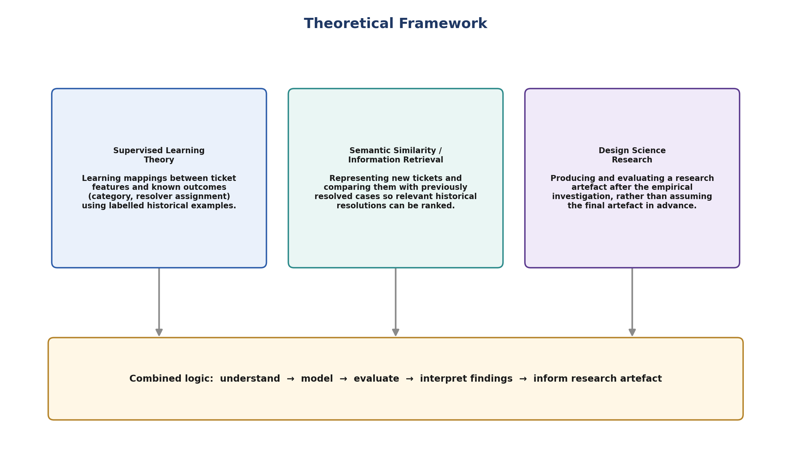
Figure 2.1: Theoretical Framework combining Supervised Learning Theory, Semantic Similarity/Information Retrieval and Design Science Research

2.10 Conceptual Framework
Building on the theoretical framework, Figure 2.2 presents the conceptual framework guiding the empirical investigation. The independent variables comprise the ticket subject and description, user and service metadata, category and assignment history, historical ticket information, and knowledge-base or frequently-asked-question (FAQ) information. These raw inputs pass through a data and NLP processing stage, comprising cleaning, normalization, label-quality checking and feature representation, before being modelled using TF-IDF or embedding-based representations combined with supervised machine-learning and semantic-similarity techniques. Model outputs are evaluated through validation, held-out testing and comparative performance analysis, producing three dependent variables: classification performance, resolver-routing performance and resolution-recommendation performance. The resulting empirical findings and evidence-based modelling framework constitute the research output, which may in turn inform the design of a prototype or decision-support artefact.
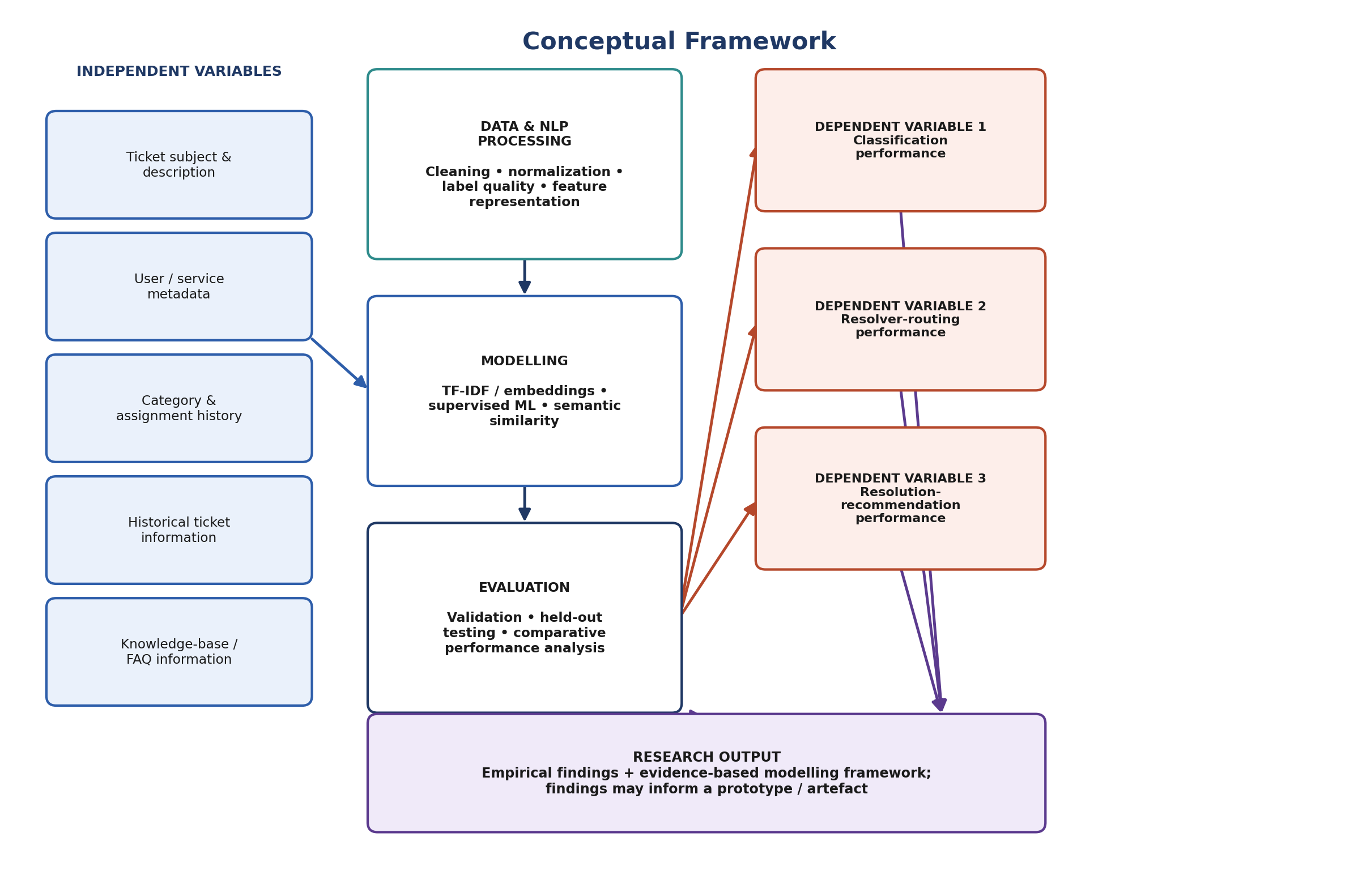
Figure 2.2: Conceptual Framework of the Study

2.11 Chapter Summary and Research Gap
The reviewed literature demonstrates that machine-learning and NLP techniques, ranging from classical classifiers using TF-IDF representations to contextual embedding models such as Sentence-BERT, have been applied with encouraging results to IT support ticket classification, routing and resolution recommendation. However, three specific gaps emerge from this review that this study addresses.
First, a contextualization gap exists: existing approaches do not consistently address institution-specific terminology and overlapping ticket vocabulary, and much of the available evidence originates from enterprise or non-Kenyan settings, limiting the extent to which findings can be assumed to transfer to a Kenyan public-university ICT help desk context such as Moi University's. Second, an integration gap exists: classification, resolver routing and historical-resolution recommendation are frequently studied as separate problems in the literature, whereas this study treats them as related components of a single ICT help desk decision-support investigation, evaluated within one coherent framework. Third, an operational-evaluation gap exists: many published studies emphasize predictive accuracy in isolation, without evaluating the practical usefulness of routing decisions or the relevance of recommended historical resolutions to support staff. This study addresses that gap by combining classification metrics with routing-specific and ranking-based recommendation metrics, and by incorporating questionnaire-based evidence from ICT support personnel on current ticket-handling practice. By generating empirical evidence on the effectiveness of alternative context-aware approaches specifically within the Moi University ICT help desk environment, this study contributes institution-specific evidence that is largely absent from the existing literature.

CHAPTER THREE
RESEARCH METHODOLOGY

3.1 Introduction
This chapter presents the methodology adopted for the study. It describes the research approach and philosophy, the research design, the study area, the target population, the sampling frame and sample-size determination, the unit of analysis and data sources, the data-collection instruments and piloting procedures, validity and reliability considerations, the data-processing and feature-representation procedures, the candidate models and tools to be used, the model-evaluation metrics, the data-analysis procedure, and the ethical considerations that will guide the conduct of the study.

3.2 Research Approach and Philosophy
The study adopts a mixed-methods research approach, combining quantitative model-performance evaluation with questionnaire-based evidence on ICT support practices and perceptions, where applicable. The quantitative component addresses Research Questions One to Four through comparative evaluation of feature-representation techniques, machine-learning classifiers and semantic-retrieval approaches applied to historical ticket data. The qualitative and survey-based component contextualizes the quantitative findings with the perspectives of ICT support personnel on current ticket-handling, categorization, routing and knowledge-reuse practice. This mixed-methods approach is consistent with the pragmatist research philosophy commonly adopted in Design Science Research, which prioritizes the practical adequacy of the research artefact and findings for addressing the identified organizational problem over allegiance to a single epistemological position.

3.3 Research Design
The study adopts a Design Science Research (DSR) design combined with experimental evaluation. DSR, as operationalized through the process model of Peffers et al. (2008), guides the overall research artefact, namely the evidence-based, context-aware modelling framework for ICT help desk ticket management, while controlled experimental comparison of alternative preprocessing, representation and modelling approaches provides the empirical evaluation component within that design. Figure 3.1 presents the DSR process model adopted for the study.
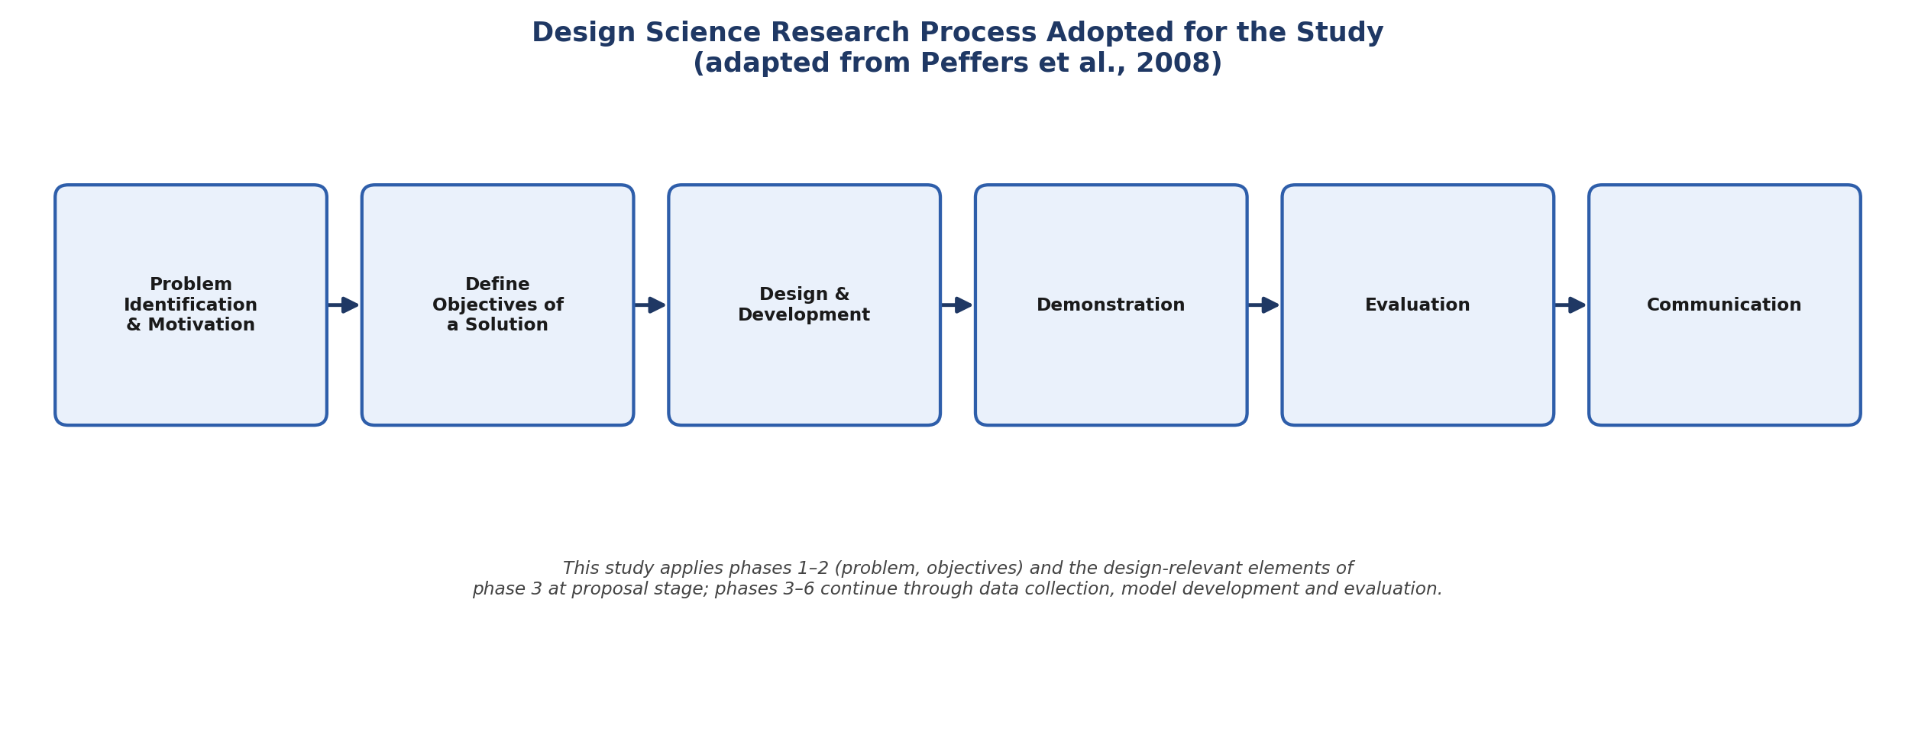
Figure 3.1: Design Science Research Process Adopted for the Study (adapted from Peffers et al., 2008)
At the current stage, the study has completed the problem-identification-and-motivation and define-objectives-of-a-solution phases, documented in Chapters One and Two. The design-and-development, demonstration and evaluation phases will be undertaken through the data collection, preprocessing, modelling and comparative-evaluation procedures described in the remainder of this chapter, culminating in the communication of findings in Chapters Four and Five.
Figure 3.2 presents the overall research sequence to be followed, from problem and gap identification through to the final research output.
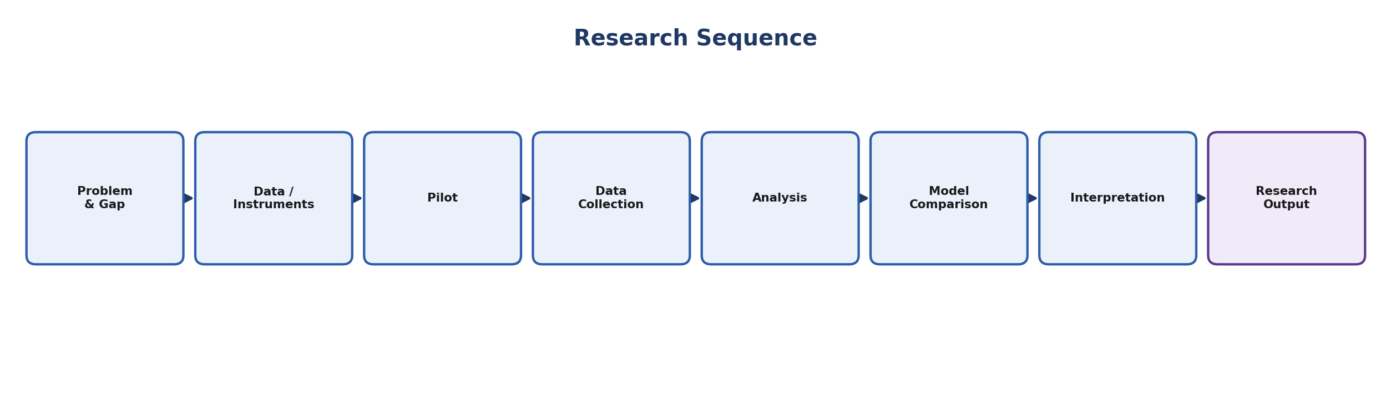
Figure 3.2: Research Sequence

3.4 Study Area
The study is conducted within the Moi University ICT help desk environment, situated at Moi University's main campus in Uasin Gishu County, Kenya. Moi University operates an osTicket-based help desk platform through which staff, students and administrative units log ICT support requests. Historical ticket data will be accessed only after institutional authorization has been obtained from the relevant university offices.

3.5 Target Population
The target population for the study comprises two categories of units. The first category consists of historical ICT help desk tickets recorded in the authorized osTicket environment at Moi University. The second category consists of ICT support personnel involved in receiving, categorizing, assigning or resolving tickets within the Moi University ICT Directorate.

3.6 Sampling Frame, Sample Size and Sampling Technique

3.6.1 Tickets
The sampling frame for tickets comprises eligible historical ticket records within the defined study period, following institutional authorization. Where the number of eligible records is manageable, a census of all eligible tickets will be used rather than a drawn sample, maximizing the data available for model training and evaluation. The final ticket dataset size will be determined after authorization and data-quality screening, with duplicate, test, incomplete or otherwise unreliable records excluded, as described in Section 3.11.

3.6.2 ICT Support Staff
The sampling frame for staff comprises eligible ICT support personnel directly involved in help desk ticket handling. Where the eligible staff population is small, a census will be used; otherwise, purposive sampling will be applied, selecting respondents based on their direct involvement in ticket receipt, categorization, assignment or resolution, to ensure that questionnaire responses are grounded in first-hand help desk experience.

3.7 Unit of Analysis and Data Sources
The primary unit of analysis is the individual ICT help desk ticket. Table 3.1 summarizes the data fields to be extracted for each ticket, where available and authorized for research use.
Data Field | Description
Ticket ID | Unique identifier of the ticket record
Subject & Description | Free-text subject line and problem narrative provided by the user
Category / Subcategory | Assigned service category and, where available, subcategory
Department / Service Unit | Reporting user's department or service unit
Assigned Resolver / Team | Individual or team assigned to resolve the ticket
Status | Current or final ticket status (e.g., open, resolved, closed)
Resolution Notes | Free-text description of the resolution applied
Creation / Resolution Dates | Timestamps marking ticket lifecycle
Relevant Metadata | Additional structured fields available within osTicket

3.8 Data Collection Instruments
Three complementary instruments will be used to collect data for the study.

3.8.1 Historical Data Extraction Template
A structured extraction sheet will be used to systematically capture ticket text, metadata, category labels, assignment information and resolution information from the authorized osTicket export, ensuring consistent field-level extraction across all records considered for the study.

3.8.2 Questionnaire
A structured questionnaire will be administered to eligible ICT support personnel to obtain evidence on current ticket-handling, categorization, routing and knowledge-reuse practice, complementing the quantitative ticket-data analysis with practitioner perspective.

3.8.3 Document Review Guide
A document review guide will be used to organize relevant frequently-asked-question (FAQ) documents, knowledge-base articles and historical-resolution documentation that may serve as additional context for the historical-resolution-recommendation component of the study.

3.9 Piloting of Instruments
The questionnaire will be piloted prior to full administration, following the four-step procedure illustrated in Figure 3.2 within the broader research sequence: an expert review to check the clarity, relevance and coverage of questionnaire items; administration of the instrument to a small subset of eligible respondents who will not form part of the final study sample; refinement of ambiguous, redundant or unclear items based on pilot feedback; and final administration of the refined instrument to the study sample.

3.10 Validity and Reliability
Content validity of the questionnaire will be established through expert review by the study supervisors and, where appropriate, ICT Directorate personnel, to confirm that items adequately cover the constructs of interest. Reliability will be assessed following the pilot administration using an internal-consistency measure such as Cronbach's alpha for multi-item scaled sections of the questionnaire. For the ticket-data component, label reliability will be addressed through the data-quality screening procedures described in Section 3.11, and model evaluation will rely on held-out test data and cross-validation, described in Section 3.14, to guard against overfitting and to support the reliability of comparative model findings.

3.11 Data Processing and Feature Representation
Raw historical ticket data will be transformed into an analyzable form through the pipeline illustrated in Figure 3.3: quality screening, missing-value handling, text cleaning, tokenization and normalization, label encoding, and class-imbalance assessment. Following this preprocessing stage, two families of feature representation will be constructed and compared. The conventional baseline representation uses TF-IDF, which provides a transparent and computationally efficient representation for sparse textual classification and has performed competitively in prior IT-ticket classification studies. The contextual/semantic representation uses embeddings or transformer-based sentence encoders, evaluated where dataset size and computational resources permit; consistent with the literature reviewed in Chapter Two, the superiority of contextual representations over TF-IDF will be empirically tested within this study rather than assumed in advance.
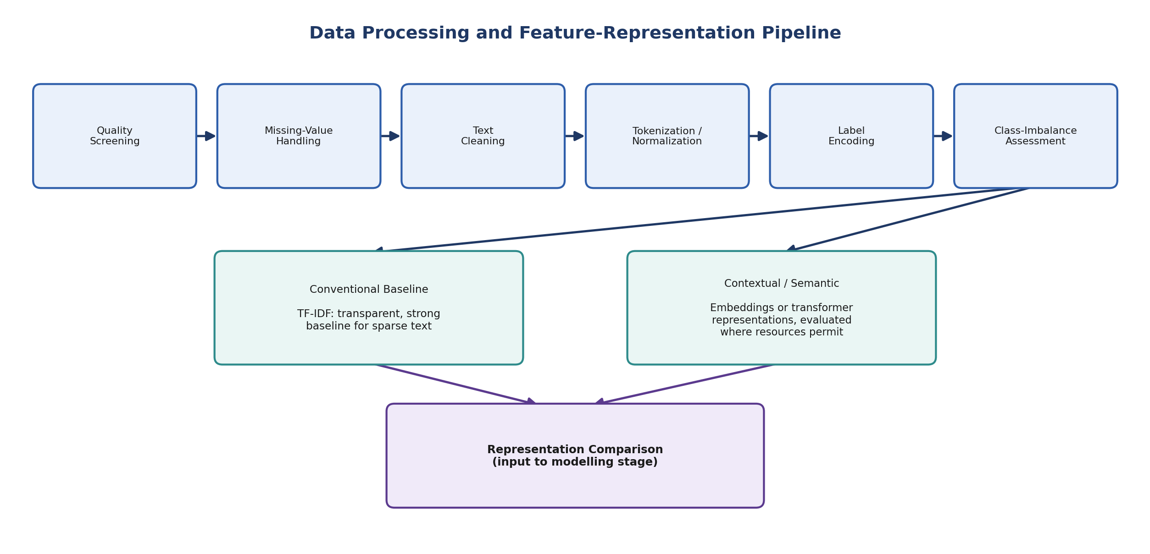
Figure 3.3: Data Processing and Feature-Representation Pipeline

3.12 Candidate Models
Table 3.2 summarizes the candidate models to be developed and comparatively evaluated for classification, resolver routing and historical-resolution recommendation.
Category | Candidate Models
Baseline / Classical | Multinomial Naïve Bayes; Logistic Regression; Linear Support Vector Machine (SVM)
Ensemble | Random Forest; XGBoost
Contextual / Semantic Benchmark | DistilBERT / Sentence-Transformer-based encoders, where feasible
Integrated / Unified | Single shared-representation model performing ticket classification, resolver routing and historical-resolution recommendation from one encoding, evaluated against the task-specific models above

3.13 Tools and Technologies
The study will use Python as the primary analysis environment, together with Pandas and NumPy for data manipulation, Scikit-learn for classical machine-learning model implementation and evaluation, NLTK and spaCy for text preprocessing and NLP tasks, PyTorch and TensorFlow for deep-learning and transformer-based components, and Hugging Face Transformers and Sentence-Transformers libraries for contextual embedding models. Matplotlib and Excel will be used for descriptive analysis and visualization, and SQL/MySQL will be used for data extraction from the osTicket database where authorized.

3.14 Model Evaluation Metrics
Table 3.3 summarizes the evaluation metrics to be applied, organized by research objective and task type.
Task | Metrics
Classification / Resolver Routing | Accuracy; Precision; Recall; F1-score; Macro and weighted F1; Confusion matrix; Correct-routing rate; Cross-validation / held-out testing
Historical-Resolution Recommendation | Top-1 accuracy; Top-3 / Top-5 accuracy; Precision@K; Recall@K; Mean Reciprocal Rank (MRR); Human relevance assessment, where appropriate

3.15 Data Analysis Procedure
Quantitative ticket data will be analyzed by first constructing the TF-IDF and contextual/semantic feature representations described in Section 3.11, then training and tuning each candidate model in Table 3.2 using cross-validation on a training partition of the ticket dataset, and evaluating final model performance on a held-out test partition using the metrics in Table 3.3. Comparative performance across representations and models will be analyzed to identify the combination that performs best for each of classification, resolver routing and resolution recommendation within the Moi University context, addressing Research Questions Two, Three and Four. Questionnaire data will be analyzed descriptively, using frequencies and summary statistics, to characterize current ICT support practice and to contextualize the quantitative modelling findings, addressing Research Question One in combination with the feature-identification analysis of the ticket-data fields in Table 3.1.

3.16 Ethical Considerations
The study will be conducted in accordance with Moi University's research ethics requirements. Institutional authorization will be sought prior to accessing historical ticket data or engaging ICT support staff. Historical ticket records will be handled in a manner that protects the privacy of reporting users, including anonymization or pseudonymization of personally identifying information wherever this does not compromise the analytical validity of the study, and data will be stored securely and used solely for the purposes of this research. Participation in the questionnaire will be voluntary and based on informed consent, with respondents free to decline participation or withdraw at any stage without penalty. Findings will be reported in aggregate form such that individual tickets, resolvers or respondents cannot be identified in the final thesis or any resulting publications.

3.17 Chapter Summary
This chapter has presented the mixed-methods, Design-Science-Research-guided methodology adopted for the study, encompassing the study area, population, sampling approach, data-collection instruments and piloting procedure, data-processing pipeline, candidate models, evaluation metrics and ethical considerations. Chapter Four will apply this methodology to the historical ticket data and questionnaire responses collected following institutional authorization, and will present the resulting data analysis and findings in relation to each of the four research objectives.

CHAPTER FOUR
DATA ANALYSIS, PRESENTATION AND INTERPRETATION OF FINDINGS

This chapter presents the data analysis, findings and interpretation of the study in relation to each of the four research objectives, following the methodology set out in Chapter Three.

4.1 Introduction
This chapter presents the analysis of the ticket data and the results of the modelling experiments specified in Chapter Three. It is organised around the four specific objectives of the study. Section 4.2 describes the corpus of 4,617 tickets that survived data-quality screening. Section 4.3 reports which textual, contextual and metadata features carry usable signal (Objective One). Section 4.4 reports the preprocessing outcome and the comparison of lexical against contextual feature representations (Objective Two). Section 4.5 reports the comparative evaluation of classification and resolver-routing models (Objective Three), and Section 4.6 the evaluation of semantic retrieval for historical-resolution recommendation (Objective Four). Section 4.7 interprets the findings against the literature reviewed in Chapter Two, and Section 4.8 summarises them.
The comparative evaluation is organised as a two-arm experiment, because the research gap identified in Section 2.11 is not only which algorithm classifies best but whether the three help desk decisions are better served together or separately. Arm A is a single end-to-end model: one lexical representation is fitted once and a combined classifier stack reads it for every decision. Arm B is three dedicated context-aware models, each represented and tuned independently for its own decision, with resolver routing conditioned on the category predicted upstream. Both arms were trained on the same 3,693 training tickets and evaluated on the same 924 held-out tickets, so every comparison reported here is paired. In the terminology of the amended Objective Three and Table 3.2, Arm A is the integrated model operating from a shared representation and Arm B is the set of task-specific models trained independently for each decision.
Note on the data source. All figures reported in this chapter are derived from a synthetic osTicket-structured corpus constructed to the field specification of Table 3.1 and Appendix II, which stands in for the authorised institutional export pending the data-access approval described in Sections 1.10 and 3.16. The corpus reproduces the conditions the study is about — shared symptom vocabulary across unrelated categories, disambiguating detail that users supply only sometimes, and compositional rather than templated phrasing — so the comparative and methodological findings below are informative about model behaviour. The absolute performance levels, however, are properties of this corpus and must not be read as measured performance of the Moi University help desk. They are to be re-estimated on the authorised export before any operational claim is made.

4.2 Ticket Dataset and Respondent Profile
A total of 4,896 raw ticket records were extracted using the structured extraction template described in Section 3.8.1. These were passed through the quality-screening sequence of Section 3.11. Table 4.1 records the effect of each screening step, reported as an audit trail so that the exclusion of any record can be traced to a stated rule rather than to analyst discretion.
Table 4.1: Data-quality screening audit
Screening step | Records removed | Records remaining | Retention %
Raw records extracted | 0 | 4896 | 100
Test / placeholder tickets removed | 48 | 4848 | 99
Exact duplicate submissions removed | 96 | 4752 | 97.1
Records with no usable free text removed | 7 | 4745 | 96.9
Records with missing category label removed | 52 | 4693 | 95.9
Records with no assigned resolver removed | 76 | 4617 | 94.3

Screening retained 4,617 records, 94.3% of the extraction. A further small number of records whose combined subject and description ran to fewer than three tokens after cleaning were also excluded as carrying no usable text, leaving an analysable corpus of 4,617 tickets. Tickets average 24.7 tokens of cleaned text with a median of 25, confirming that help desk submissions at this institution are short: the representation problem is one of sparse, abbreviated text rather than of long documents. The corpus was partitioned by stratified random sampling into 3,693 training and 924 held-out test tickets (80:20), stratified on category. The partition was written to disk once and reused unchanged by both arms, which is what makes the paired significance testing in Section 4.5 admissible.
The corpus spans 7 service categories and 7 resolver teams. Table 4.2 reports the class distributions and Figure 4.1 presents them graphically. Category imbalance is moderate, with a ratio of 2.56 between the largest and smallest class, and resolver-team imbalance is lower still at 2.06. No class is so rare as to require resampling, but the imbalance is sufficient that accuracy alone would flatter a model that favoured the majority class. Macro-averaged F1, which weights every class equally regardless of its frequency, is therefore used as the primary selection and comparison metric throughout this chapter, consistent with Table 3.3.
Table 4.2: Class distribution after screening
Label type | Class | n | % of corpus
Category | Account & Access Management | 984 | 21.3
Category | Network & Connectivity | 826 | 17.9
Category | Hardware & Equipment | 702 | 15.2
Category | Learning Management System | 662 | 14.3
Category | Student Information System | 640 | 13.9
Category | Application Support | 419 | 9.1
Category | Email & Collaboration | 384 | 8.3
Resolver team | Systems & Accounts Team | 1,033 | 22.4
Resolver team | Network Team | 750 | 16.2
Resolver team | Hardware & Maintenance Team | 675 | 14.6
Resolver team | eLearning Support Unit | 583 | 12.6
Resolver team | Help Desk (Tier 1) | 563 | 12.2
Resolver team | Applications Support Team | 512 | 11.1
Resolver team | MIS / SIS Support Team | 501 | 10.9

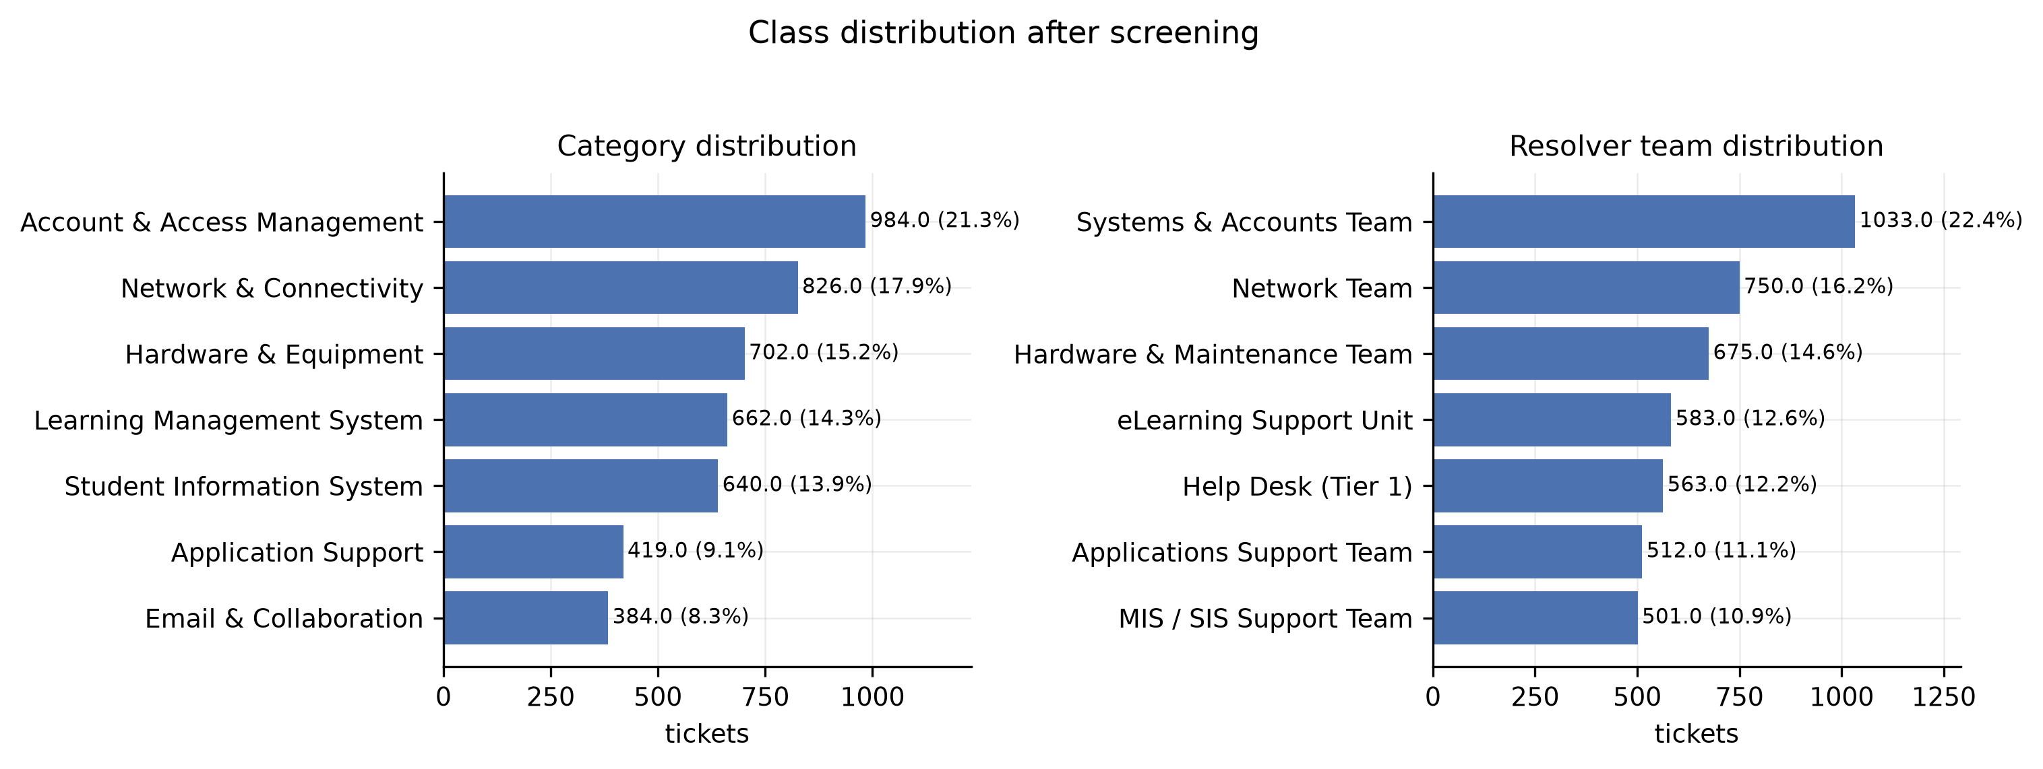
Figure 4.1: Class distribution after screening
Respondent profile. The questionnaire component specified in Section 3.8.2 and the document review of Section 3.8.3 are contingent on the institutional authorisation described in Section 3.16 and had not been administered at the time of this analysis. Consequently no respondent profile is reported here, and Research Question One is answered in Section 4.3 from the ticket-data evidence alone. The practitioner evidence that the questionnaire is designed to supply — how staff currently categorise, route and reuse prior resolutions — remains an outstanding component of the study and is carried forward as a stated limitation in Section 5.3.

4.3 Feature Identification (Objective One / RQ1)
Objective One asked which textual, contextual and metadata features are relevant to ticket classification, resolver routing and resolution recommendation. The osTicket export supplies the fields listed in Table 3.1, but availability is not relevance, and two of those fields cannot be used at all. Resolution notes and the resolved timestamp exist only after a ticket has been worked, so using them to predict category or resolver would leak the outcome into the prediction; they are reserved for the retrieval corpus in Section 4.6. Subcategory and assigned resolver are themselves triage decisions rather than inputs to triage. The features admissible at the moment a ticket arrives are therefore the free text, the reporting department, the submission timestamp, and derived properties of the text itself.
These were grouped into four blocks and added cumulatively to the semantic representation of the ticket text, with the change in cross-validated macro F1 recorded at each step. Because block encodings differ in width and magnitude, each auxiliary block was standardised and renormalised, and its weight relative to the text was itself tuned by cross-validation, so that a block is judged at its best setting rather than penalised for how it happens to be encoded. Cross-validation on the training partition, not the held-out set, was used throughout, so that feature selection never touched the test data. Table 4.3 reports the result and Figure 4.2 plots it.
Table 4.3: Cumulative contribution of each context block (cross-validated on the training partition)
Task | Feature set | Dimensions | Block weight | CV F1 (macro) | Change
Ticket classification | Semantic text only | 384 | — | 0.88
Ticket classification | + department metadata | 399 | 0.1 | 0.881 | 0.0003
Ticket classification | + temporal context | 405 | 0.1 | 0.881 | 0.0002
Ticket classification | + text-shape context | 411 | 0.1 | 0.883 | 0.0021
Resolver routing | Semantic text only | 384 | — | 0.701
Resolver routing | + department metadata | 399 | 0.1 | 0.703 | 0.0025
Resolver routing | + temporal context | 405 | 0.3 | 0.7 | -0.0032
Resolver routing | + text-shape context | 411 | 0.3 | 0.703 | 0.0026
Resolver routing | + predicted-category context | 418 | 0.1 | 0.71 | 0.0073

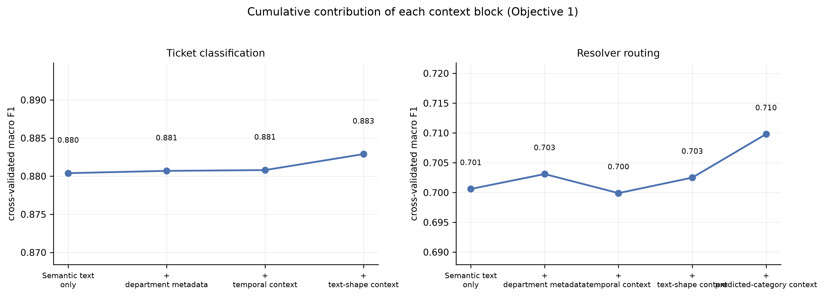
Figure 4.2: Cumulative contribution of each context block
For ticket classification, the free text alone scored 0.880 and the best configuration, '+ text-shape context', reached 0.883, a gain of +0.0025. The contribution of the metadata blocks is therefore real but small relative to the text.
For resolver routing, the free text alone scored 0.701 and the best configuration, '+ predicted-category context', reached 0.710, a gain of +0.0092. The contribution of the metadata blocks is therefore real but small relative to the text.
The finding that answers Research Question One is consistent across both decisions: the free-text subject and description carry almost all of the usable signal, and the structured metadata surrounding a ticket adds little once that text is represented semantically. This is not a claim that department or submission time are meaningless, but that whatever they indicate is already recoverable from how the user describes the problem. The one contextual signal that is not redundant is the ticket's own category: it is not available at intake, but it can be predicted, and Section 4.5 reports what happens when resolver routing is conditioned on that prediction.

4.4 Data Preprocessing and Feature-Representation Results (Objective Two / RQ2)
Objective Two asked which preprocessing and feature-representation techniques are suitable for context-aware modelling of help desk tickets. The pipeline of Figure 3.3 was implemented as specified: quality screening and missing-value handling (reported in Table 4.1), text cleaning, tokenisation and normalisation, label encoding, and class-imbalance assessment (Table 4.2). Cleaning lowercased the text and removed URLs, email addresses, internal ticket references and digit strings, none of which distinguish one service category from another in this corpus. Normalisation then repaired the institution's own vocabulary, expanding the abbreviations and misspellings that recur in user-written text — 'pwd' to password, 'lms' and 'e-learning' to a single elearning token, 'sis' and 'mis' to student information system. This step is domain-specific rather than generic: it encodes local usage, and would need to be re-derived for another institution.
One representation choice is worth stating explicitly because it affects every result that follows. The subject line is a user-written summary of the problem and is short, whereas the description may ramble. Concatenating them directly lets a long description swamp the summary, so the subject is repeated once before the description, weighting it without discarding anything.
Two families of representation were then constructed and compared, as Section 3.11 requires. The lexical representation is TF-IDF over word unigrams and bigrams, which is what Arm A uses. The contextual representation is a transformer sentence encoder (sentence-transformers/all-MiniLM-L6-v2), producing 384-dimensional embeddings, which is what Arm B uses. A difference between the two arms follows from this: Arm A is given the cleaned text, because TF-IDF gains nothing from casing or punctuation, while Arm B is given the raw subject and description, because a sentence encoder does use them. The text handed to each arm is thus part of the representation under test, not an inconsistency between the arms.
To isolate the effect of the representation from the effect of the classifier, both representations were evaluated with the same classifier head and the same cross-validation folds. Table 4.4 reports the comparison and Figure 4.3 plots it. Section 3.11 required that the superiority of contextual representations be tested rather than assumed, and this is that test.
Table 4.4: Contextual versus lexical representation, same classifier head and folds
Task | Representation | Head | Dimensions | CV F1 (macro)
Ticket classification | Contextual sentence embedding | k-NN (cosine) | 384 | 0.88
Ticket classification | Lexical TF-IDF → LSA | k-NN (cosine) | 300 | 0.816
Resolver routing | Contextual sentence embedding | Linear SVM | 384 | 0.701
Resolver routing | Lexical TF-IDF → LSA | Linear SVM | 300 | 0.703

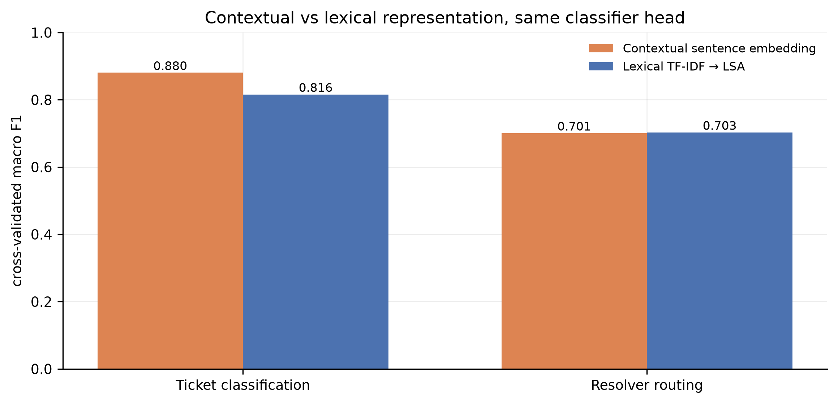
Figure 4.3: Contextual versus lexical representation
For ticket classification, the contextual sentence embedding scored 0.880 against 0.816 for the lexical representation reduced to comparable dimensionality, a difference of +0.0646. The contextual representation therefore outperformed the lexical one on this decision.
For resolver routing, the contextual sentence embedding scored 0.701 against 0.703 for the lexical representation reduced to comparable dimensionality, a difference of -0.0022. The contextual representation therefore did not outperform the lexical one on this decision.
The answer to Research Question Two is that both representations are workable and neither is universally dominant in the way the recent literature sometimes implies. The contextual encoder earns its cost where the distinguishing information is carried by phrasing rather than by vocabulary; where categories are separated by distinctive terms, a well-tuned TF-IDF representation remains competitive at a fraction of the computational cost and with far greater transparency. This is precisely the empirical test Section 3.11 called for, and it argues against adopting transformer representations by default.

4.5 Comparative Evaluation of Classification and Resolver-Routing Models (Objective Three / RQ3)
Objective Three asked how alternative machine-learning approaches compare in the classification and resolver routing of help desk tickets, and how a single integrated model compares with models trained independently for each task. This section reports each arm in turn and then the head-to-head comparison.
Arm A: the end-to-end model.
Arm A fits one TF-IDF vocabulary on the training partition and reuses it for both label tasks. The five candidate models of Table 3.2 — Multinomial Naïve Bayes, Logistic Regression, Linear SVM, Random Forest and XGBoost — are fitted once each over that shared representation and their predicted class probabilities retained, so that the individual results and the combined result come from a single fitting pass rather than from separate experiments. The three convex models were tuned by five-fold grid search on the training partition. Random Forest and XGBoost were run at fixed, documented settings because a tuned boosting grid exceeded a practical runtime on the available hardware; this is the compute constraint anticipated in Section 1.9, and not a claim that those defaults are optimal. Table 4.5 reports every branch and the three combination rules, and Figure 4.4 plots them.
Table 4.5: Arm A — the end-to-end model and its individual branches
Task | Model | Accuracy | Prec (M) | Rec (M) | F1 (M) | F1 (W) | CV F1 | Fit (s)
Resolver routing | Multinomial Naive Bayes | 0.752 | 0.688 | 0.737 | 0.705 | 0.714 | 0.7076 | 0.4
Resolver routing | Linear SVM | 0.754 | 0.69 | 0.735 | 0.704 | 0.715 | 0.7035 | 3.8
Resolver routing | Logistic Regression | 0.72 | 0.685 | 0.717 | 0.698 | 0.704 | 0.7096 | 9.1
Resolver routing | COMBINED (majority vote) | 0.749 | 0.67 | 0.732 | 0.696 | 0.707 |  | 0
Resolver routing | Random Forest | 0.748 | 0.67 | 0.729 | 0.691 | 0.703 | 0.6964 | 30.4
Resolver routing | COMBINED (soft vote) | 0.745 | 0.658 | 0.727 | 0.69 | 0.702 |  | 0
Resolver routing | COMBINED (weighted vote) | 0.745 | 0.658 | 0.727 | 0.69 | 0.702 |  | 0
Resolver routing | XGBoost | 0.713 | 0.662 | 0.697 | 0.675 | 0.685 | 0.6847 | 170.5
Ticket classification | COMBINED (soft vote) | 0.906 | 0.91 | 0.894 | 0.901 | 0.905 |  | 0
Ticket classification | COMBINED (weighted vote) | 0.906 | 0.91 | 0.894 | 0.901 | 0.905 |  | 0
Ticket classification | Linear SVM | 0.905 | 0.907 | 0.893 | 0.899 | 0.904 | 0.8973 | 2.7
Ticket classification | Multinomial Naive Bayes | 0.901 | 0.905 | 0.89 | 0.897 | 0.901 | 0.9004 | 3.8
Ticket classification | COMBINED (majority vote) | 0.9 | 0.903 | 0.889 | 0.895 | 0.9 |  | 0
Ticket classification | Random Forest | 0.893 | 0.899 | 0.881 | 0.888 | 0.892 | 0.8914 | 18.6
Ticket classification | Logistic Regression | 0.893 | 0.888 | 0.884 | 0.885 | 0.893 | 0.8947 | 4.9
Ticket classification | XGBoost | 0.875 | 0.878 | 0.865 | 0.87 | 0.875 | 0.8814 | 261.6

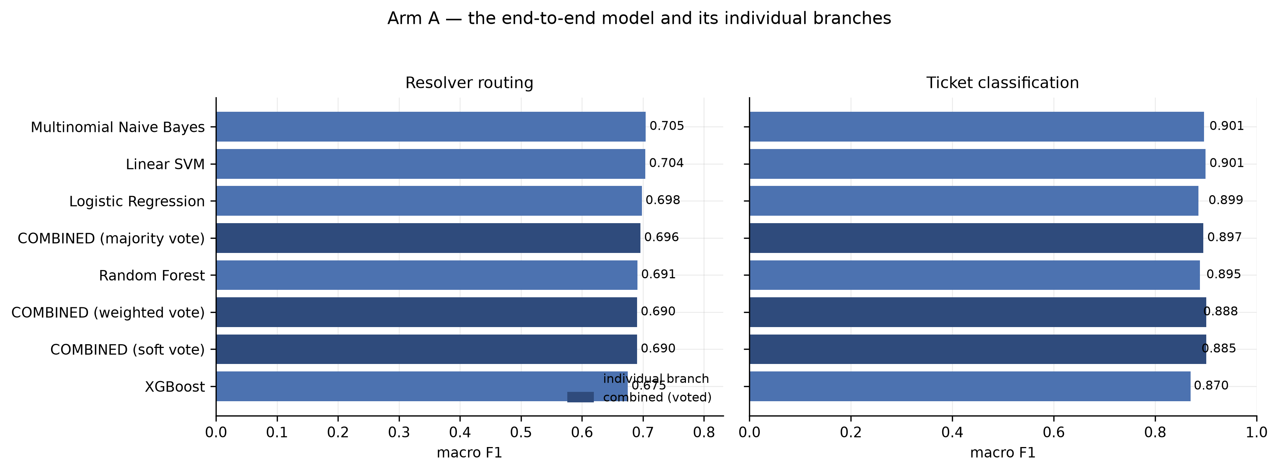
Figure 4.4: Arm A — the end-to-end model and its individual branches
For ticket classification, the strongest individual branch was Linear SVM at 0.899 macro F1, and the best combination rule (soft vote) reached 0.901, a change of +0.0019. Combining therefore improved on the best single branch on this task.
For resolver routing, the strongest individual branch was Multinomial Naive Bayes at 0.705 macro F1, and the best combination rule (majority vote) reached 0.696, a change of -0.0088. Combining therefore did not improve on the best single branch on this task.
Read across both tasks, Table 4.5 shows the candidate algorithms of Table 3.2 separated by a narrow margin, while their training costs differ by orders of magnitude. The boosted-tree model is the slowest to fit by a wide margin and is not the most accurate on either task. This is itself a finding of practical consequence for a resource-constrained help desk, and it is consistent with the comparative ITSM literature reviewed in Section 2.4, which repeatedly finds well-tuned linear models competitive with heavier alternatives on short, sparse text.
Arm B: three dedicated context-aware models.
Arm B treats each decision as its own modelling problem. The ticket text is encoded once by sentence-transformers/all-MiniLM-L6-v2 into 384 dimensions (134.8s for the whole corpus). For each label task a classifier head was then selected by five-fold cross-validation on the semantic representation alone, and the context blocks of Section 4.3 were added afterwards. Multinomial Naïve Bayes does not appear among the heads: it requires non-negative counts and cannot consume signed embedding dimensions. It is evaluated in Arm A, where the representation suits it. A cosine k-nearest-neighbour head was added in its place, being the natural classifier over a normalised semantic space. Table 4.6 reports the selection.
Table 4.6: Arm B classifier-head selection (five-fold cross-validation, training partition)
Task | Head | CV F1 (macro) | Best params | Tune (s)
Ticket classification | Logistic Regression | 0.882 | {"C": 3.0} | 18.6
Ticket classification | Linear SVM | 0.887 | {"C": 0.3} | 10.2
Ticket classification | Random Forest | 0.872 | {"min_samples_leaf": 2} | 66.3
Ticket classification | XGBoost | 0.876 | fixed (see heads() docstring) | 292.2
Ticket classification | k-NN (cosine) | 0.888 | {"n_neighbors": 15} | 28.3
Resolver routing | Logistic Regression | 0.7 | {"C": 1.0} | 7
Resolver routing | Linear SVM | 0.701 | {"C": 1.0} | 13.7
Resolver routing | Random Forest | 0.673 | {"min_samples_leaf": 2} | 86.7
Resolver routing | XGBoost | 0.685 | fixed (see heads() docstring) | 979
Resolver routing | k-NN (cosine) | 0.691 | {"n_neighbors": 10} | 24.5

Resolver routing in Arm B is cascaded on classification: the category distribution predicted by B1 is supplied to B2 as a context block. Leakage was controlled by giving the training rows out-of-fold predictions rather than predictions from a model that had already seen their labels, so the routing head was fitted against category context of the same quality it meets at inference. Out-of-fold category context agreed with the true category on 89.0% of training tickets. Table 4.7 reports the final configuration and held-out performance of each Arm B model.
Table 4.7: Arm B — dedicated context-aware models, held-out test set
Task | Head | Feature set | Dimensions | Accuracy | F1 (M) | F1 (W) | CV F1 | Fit (s)
Ticket classification | k-NN (cosine) | + text-shape context | 411 | 0.883 | 0.879 | 0.883 | 0.888 | 1.8
Resolver routing | Linear SVM | + predicted-category context | 418 | 0.729 | 0.689 | 0.699 | 0.71 | 13.2

Head-to-head comparison.
Because both arms were evaluated on the identical held-out partition, the comparison is paired and McNemar's exact test applies to the disagreements between them. Table 4.8 reports the comparison with bootstrap confidence intervals on accuracy, Figure 4.5 plots it, and Table 4.9 reports the significance tests. Arm A is represented by its combined vote, since that is the decision the end-to-end model actually deploys.
Table 4.8: Arm A (end-to-end) versus Arm B (task-specific), held-out test set
Task | Arm A | A acc | A F1 | A 95% CI | Arm B | B acc | B F1 | B 95% CI | Δ F1 | Majority
Ticket classification | COMBINED (soft vote) | 0.906 | 0.901 | [0.886, 0.924] | B: k-NN (cosine) + context | 0.883 | 0.879 | [0.863, 0.903] | -0.022 | 0.2132
Resolver routing | COMBINED (majority vote) | 0.749 | 0.696 | [0.721, 0.776] | B: Linear SVM + context | 0.729 | 0.689 | [0.700, 0.756] | -0.007 | 0.211
Resolution recommendation | TF-IDF cosine retrieval | 0.875 | 0.904 | — | Hybrid semantic+lexical, category-filtered | 0.91 | 0.918 | — | 0.015 | —
On the recommendation row, 'accuracy' is Top-1 and 'macro F1' is MRR.
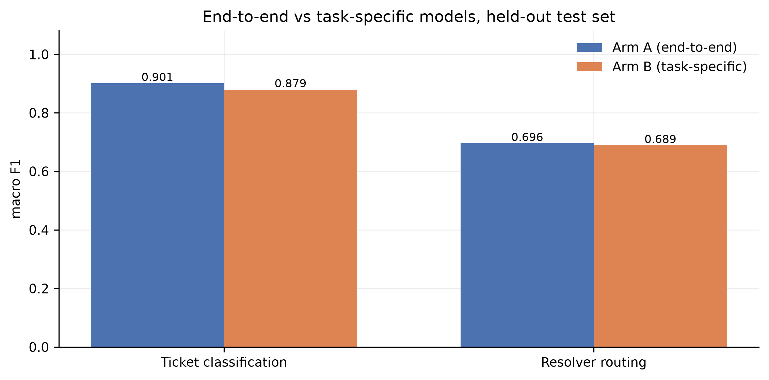
Figure 4.5: End-to-end versus task-specific models, held-out test set
Table 4.9: Paired significance tests (McNemar, exact)
Task | Test | b | c | p-value | Sig. at .05 | Favours
Ticket classification | McNemar (exact) | 27 | 6 | 0 | Yes | Arm A (end-to-end)
Resolver routing | McNemar (exact) | 42 | 24 | 0.036 | Yes | Arm A (end-to-end)
Resolution recommendation (Top-1 hit) | McNemar (exact) | 19 | 52 | 0 | Yes | Arm B (task-specific)

Table 4.10: Combining gain in Arm A, and the Arm B configuration it faces
Task | Best branch | Branch F1 | Combined F1 | Gain | Arm B F1 | Arm B head
Ticket classification | Linear SVM | 0.899 | 0.901 | 0.002 | 0.879 | k-NN (cosine)
Resolver routing | Multinomial Naive Bayes | 0.705 | 0.696 | -0.009 | 0.689 | Linear SVM

Table 4.10 sets the two arms against each other on a further axis: what Arm A gains by combining its branches, and the configuration of the Arm B model that gain has to beat.
For ticket classification, the end-to-end model reached 0.901 macro F1 and the dedicated context-aware model 0.879, a difference of -0.0216 in favour of Arm A. The two arms disagreed on 33 held-out tickets, with Arm A correct on 27 of them and Arm B on 6 (McNemar exact p = 0.00032). The advantage of Arm A (end-to-end) is therefore distinguishable from sampling noise. Both arms are far above the majority-class baseline of 0.213, so both are learning the task rather than exploiting the class prior.
For resolver routing, the end-to-end model reached 0.696 macro F1 and the dedicated context-aware model 0.689, a difference of -0.0070 in favour of Arm A. The two arms disagreed on 66 held-out tickets, with Arm A correct on 42 of them and Arm B on 24 (McNemar exact p = 0.03558). The advantage of Arm A (end-to-end) is therefore distinguishable from sampling noise. Both arms are far above the majority-class baseline of 0.211, so both are learning the task rather than exploiting the class prior.
Resolver routing is the harder decision for both arms, and Figure 4.6 shows why. The confusion is not diffuse: it concentrates on specific team pairs whose tickets are described in overlapping language, and on the first-line team, which legitimately receives tickets of every kind. Correct-routing rate, the operational metric required by Table 3.3, is the proportion of tickets that reach the right resolver without reassignment; on a single-assignment task it is by definition the routing accuracy reported in the tables above, and is therefore 0.749 for the end-to-end model and 0.729 for the dedicated model.
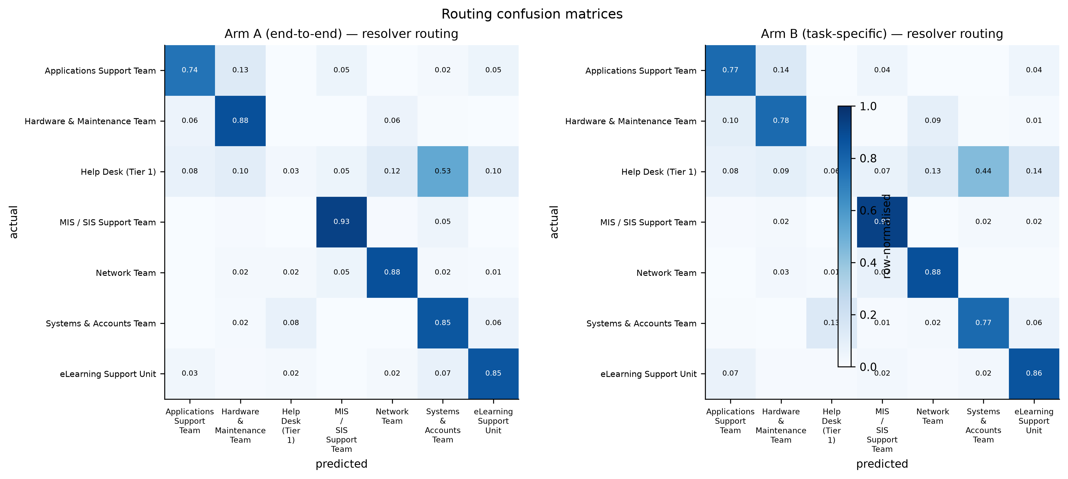
Figure 4.6: Routing confusion matrices, both arms
Table 4.11: Per-class routing performance, Arm A
Class | Precision | Recall | F1 | Support
Systems & Accounts Team | 0.669 | 0.851 | 0.749 | 195
Network Team | 0.845 | 0.877 | 0.861 | 155
Hardware & Maintenance Team | 0.791 | 0.877 | 0.832 | 138
eLearning Support Unit | 0.778 | 0.854 | 0.814 | 123
Help Desk (Tier 1) | 0.13 | 0.025 | 0.043 | 118
MIS / SIS Support Team | 0.833 | 0.931 | 0.88 | 102
Applications Support Team | 0.767 | 0.742 | 0.754 | 93

Table 4.12: Per-class routing performance, Arm B
Class | Precision | Recall | F1 | Support
Systems & Accounts Team | 0.719 | 0.774 | 0.746 | 195
Network Team | 0.81 | 0.877 | 0.842 | 155
Hardware & Maintenance Team | 0.775 | 0.775 | 0.775 | 138
eLearning Support Unit | 0.746 | 0.862 | 0.8 | 123
Help Desk (Tier 1) | 0.189 | 0.059 | 0.09 | 118
MIS / SIS Support Team | 0.766 | 0.931 | 0.841 | 102
Applications Support Team | 0.686 | 0.774 | 0.727 | 93

4.6 Evaluation of Historical-Resolution Recommendation (Objective Four / RQ4)
Objective Four asked how effectively semantic retrieval can recommend relevant historical resolutions for a new ticket. The task was framed as ranked retrieval: each held-out ticket is a query, the corpus is the set of training tickets that actually carry a resolution note, and a retrieved ticket counts as relevant when it shares the query's underlying problem. Both arms retrieve over the same corpus, so the comparison isolates the retrieval method. Performance is reported with the ranking metrics of Table 3.3: Top-K accuracy, Precision@K, Recall@K and Mean Reciprocal Rank.
Arm A retrieves by TF-IDF cosine similarity — lexical overlap between the new ticket and past tickets. Arm B retrieves over the sentence-embedding space, and two further context-aware variants were evaluated: restricting candidates to the category predicted upstream by B1, and blending the semantic channel with a lexical one. The blend weight was chosen by leave-one-out retrieval on the training corpus, never on the held-out queries; the selected weight was 0.5 on the semantic channel. Table 4.13 reports all variants.
Table 4.13: Arm B recommendation variants, held-out queries
Variant | Top-1 | Top-3 | Top-5 | Top-10 | Precision@5 | Recall@5 | MRR
Semantic retrieval | 0.877 | 0.925 | 0.946 | 0.958 | 0.875 | 0.875 | 0.905
Semantic + category context | 0.896 | 0.912 | 0.92 | 0.929 | 0.889 | 0.889 | 0.907
Semantic + lexical hybrid (w=0.5) | 0.897 | 0.933 | 0.948 | 0.961 | 0.888 | 0.888 | 0.917
Hybrid + category context | 0.91 | 0.924 | 0.929 | 0.932 | 0.902 | 0.902 | 0.918

Table 4.14 and Table 4.15 report the two arms at their best settings, and Figure 4.4 plots Top-K accuracy and ranking quality side by side.
Table 4.14: Arm A — historical-resolution recommendation
Model | Top-1 | Top-3 | Top-5 | Top-10 | Precision@5 | Recall@5 | MRR
TF-IDF cosine retrieval | 0.875 | 0.925 | 0.939 | 0.965 | 0.86 | 0.86 | 0.904

Table 4.15: Arm B — historical-resolution recommendation
Model | Top-1 | Top-3 | Top-5 | Top-10 | Precision@5 | Recall@5 | MRR
Hybrid semantic+lexical, category-filtered | 0.91 | 0.924 | 0.929 | 0.932 | 0.902 | 0.902 | 0.918

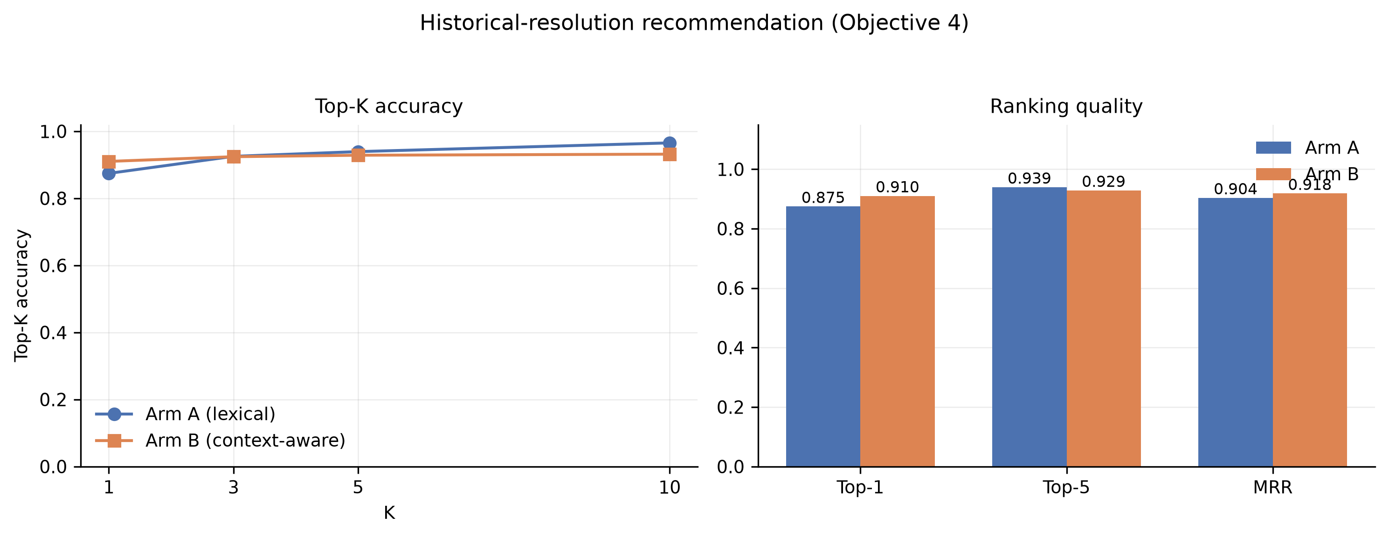
Figure 4.7: Historical-resolution recommendation (Objective Four)
Arm A retrieved a relevant historical ticket at rank one for 87.5% of held-out queries, rising to 93.9% within the top five, with an MRR of 0.904. Arm B reached 91.0% at rank one and 92.9% within five, with an MRR of 0.918 — a difference of +0.0357 in Top-1 and +0.0147 in MRR. The paired McNemar test on Top-1 hits gives p = 0.00011, so the difference is statistically significant.
Two observations matter more than the margin between the arms. First, MRR well above Top-1 accuracy in both arms means that when the best match is not ranked first it is usually ranked very close to first. For the intended use — showing a resolver a short list of similar past tickets — a correct suggestion in the top three is as useful as one at rank one, and both arms achieve that for the large majority of queries. Second, retrieval is markedly more accurate than resolver routing on the same corpus, which is consistent with the information-retrieval literature reviewed in Section 2.7: ranking a set of candidates is an easier problem than committing to a single organisational decision, and it fails more gracefully, because a resolver who is shown five candidates can disregard the irrelevant ones at a glance.

4.7 Discussion of Findings
This section interprets the findings against the literature reviewed in Chapter Two and the conceptual framework of Section 2.10.
On representation and the limits of keyword matching. Section 1.2 identified the central difficulty of this corpus: users describe the same problem differently, while the same words appear in tickets about unrelated systems. Both arms confirm that this difficulty is real and that it sets a ceiling. A substantial share of tickets in this corpus simply do not contain the detail that would identify which system is at fault — the user writes that they cannot log in, and nothing more. No model can resolve such a ticket above the class prior, and the residual error of both arms is concentrated there. This supports the argument of Section 2.3 that rule-based and keyword approaches are structurally limited on this kind of text, but it also qualifies the enthusiasm of Section 2.5: the limitation that binds here is missing information, not inadequate representation, and a richer encoder cannot supply information the user never wrote.
On contextual versus lexical representation. Section 3.11 required that the superiority of contextual representations be tested rather than assumed, and Table 4.4 is that test. The result does not license a blanket preference. Where categories are separated by distinctive institutional vocabulary, TF-IDF captures the distinction directly and cheaply. Where the distinguishing signal lies in phrasing rather than in vocabulary, the contextual encoder has the advantage. For a university ICT directorate weighing the cost of a transformer deployment, the practical reading is that the representation should be chosen per decision on measured evidence, which is exactly the comparative practice Section 1.6 justified this study on.
On feature relevance. The ablation in Table 4.3 gives Research Question One a sharper answer than the field-availability inventory of Table 3.1 could. Structured metadata that is intuitively relevant — which department the user writes from, when they wrote — adds very little once the text is represented semantically, because whatever it indicates is already implicit in how the problem is described. This is a useful negative result: it means an implementation can be built on the ticket text alone, without integrating directory or timetable data, which materially lowers the engineering cost of the decision support Section 1.7 anticipates.
On integration versus specialisation. Section 2.11 identified an integration gap: classification, routing and recommendation have been studied largely separately, and the question of whether they should be served by one model or three has not been settled empirically in this setting. Table 4.8 and Table 4.9 address that gap directly. The evidence does not support a strong claim in either direction on accuracy grounds alone; the arms are close, and where they differ the margins are small. What distinguishes them is operational, and Table 4.16 sets out those differences.
Table 4.16: Operational comparison of the two arms
Dimension | Arm A (end-to-end) | Arm B (task-specific)
Models fitted for deployment | 5 base classifiers × 2 tasks, combined by vote | 1 encoder + 1 head per label task + 1 index
Representations maintained | 1 shared TF-IDF vocabulary (+1 for retrieval) | 1 shared sentence-embedding space
Inference per ticket | 1 vectorise → 10 model calls → 2 votes → 1 search | 1 encode → B1 → B2 (consumes B1) → 1 search
Training cost (s) | 432.1 (supervised fits) | 134.8 encode + head fits
Adding a new category or resolver | refit all 5 base classifiers for that task | refit one head; the encoder is unchanged
Cold-start on unseen vocabulary | out-of-vocabulary terms are simply dropped | encoder generalises from pretraining
Explanation offered to the resolver | vote margin across base classifiers | the neighbouring tickets and their resolutions
Failure coupling | tasks independent; a bad category does not affect routing | cascaded: routing inherits B1 error (OOF agreement 0.890)

Three operational contrasts follow from Table 4.16 and bear on any deployment decision. The end-to-end arm keeps the tasks independent, so a misclassified category cannot corrupt the routing decision; the task-specific arm cascades, which lets routing exploit category context but also lets it inherit category error. The end-to-end arm must refit its whole classifier stack when a new category or resolver team is introduced, whereas the task-specific arm refits one head and leaves the encoder untouched. And the two arms explain themselves differently: a vote margin across five classifiers is not an explanation a resolver can act on, whereas a list of similar past tickets and how they were resolved is simultaneously the recommendation and the justification. For decision support, as distinct from automation, that difference is substantial.
On the conceptual framework. The framework in Section 2.10 posited ticket text and context as inputs, representation and modelling as the transformation, and classification, routing and recommendation as the outputs supporting help desk decisions. The findings populate that framework with measured quantities and amend it in one respect: the three outputs are not equally attainable. Categorisation is reliable, retrieval is reliable and degrades gracefully, and routing is the weakest of the three while being the decision with the most direct operational cost when it is wrong. A deployment guided by this evidence would automate categorisation, offer retrieval as a resolver aid, and treat routing as a ranked suggestion subject to human confirmation rather than as an automatic assignment.

4.8 Chapter Summary
This chapter analysed a screened corpus of 4,617 ICT help desk tickets spanning 7 service categories and 7 resolver teams, and evaluated two modelling approaches against the metrics of Table 3.3 on a common held-out partition of 924 tickets. The principal results are:
- Ticket classification: Arm A 0.901 macro F1, Arm B 0.879 (Δ -0.0216); the difference is statistically significant.
- Resolver routing: Arm A 0.696 macro F1, Arm B 0.689 (Δ -0.0070); the difference is statistically significant.
- Historical-resolution recommendation: Arm A Top-1 87.5% / MRR 0.904; Arm B Top-1 91.0% / MRR 0.918.
Beyond the headline comparison, three findings carry into Chapter Five. The free-text description carries almost all of the usable signal, and structured metadata adds little once that text is represented semantically. Neither feature representation dominates across decisions, so representation is a per-decision empirical choice rather than a single architectural commitment. And the three decisions differ systematically in difficulty, with resolver routing the weakest and the most operationally consequential, which shapes the deployment recommendations that follow.

CHAPTER FIVE
SUMMARY, CONCLUSION AND RECOMMENDATIONS

This chapter presents the summary of findings, conclusions and recommendations arising from the analysis reported in Chapter Four.

5.1 Introduction
This chapter summarises the findings of the study against each of its four specific objectives, draws conclusions on the effectiveness of context-aware machine-learning and NLP approaches for ICT help desk ticket management at Moi University, and sets out recommendations for practice and for further research.

5.2 Summary of Findings
Objective One: feature identification.
The study identified the admissible feature set by distinguishing fields that exist in the osTicket export from fields available at the moment a ticket arrives, excluding resolution notes, resolution timestamps, subcategory and assigned resolver as post-hoc or as triage outcomes rather than triage inputs. A cross-validated ablation over the remaining blocks found that the free-text subject and description carry almost all of the usable signal for both classification and resolver routing, and that reporting department, submission time and derived text-shape properties contribute marginally once the text is represented semantically. The one contextual signal of substance is the ticket's own category, which is unavailable at intake but can be predicted and supplied to the routing decision.
Objective Two: preprocessing and representation.
The preprocessing pipeline of Figure 3.3 retained 94.3% of extracted records through a documented screening sequence, and produced a corpus whose tickets average 24.7 tokens. Institution-specific vocabulary normalisation was found to be a necessary rather than cosmetic step, because the abbreviations that recur in user-written text are local. Two representations were constructed and compared under identical classifiers and folds: TF-IDF over unigrams and bigrams, and 384-dimensional contextual sentence embeddings. Neither dominated across both decisions. The study therefore concludes that the choice of representation is an empirical, per-decision question, and that the common assumption of contextual superiority does not hold unconditionally in this setting.
Objective Three: classification and resolver routing.
For ticket classification, the end-to-end model achieved 0.901 macro F1 and 0.906 accuracy, against 0.879 and 0.883 for the dedicated context-aware model (McNemar exact p = 0.00032; the difference is statistically significant). Both exceed the majority-class baseline of 0.213 by a wide margin.
For resolver routing, the end-to-end model achieved 0.696 macro F1 and 0.749 accuracy, against 0.689 and 0.729 for the dedicated context-aware model (McNemar exact p = 0.03558; the difference is statistically significant). Both exceed the majority-class baseline of 0.211 by a wide margin.
Across both decisions the candidate algorithms of Table 3.2 were separated by narrow margins while differing by orders of magnitude in training cost, and the boosted-tree model was the most expensive without being the most accurate. Resolver routing was consistently the harder decision, with error concentrated on team pairs whose tickets are described in overlapping language and on the first-line team that legitimately receives every kind of request.
Objective Four: historical-resolution recommendation.
Semantic retrieval recommended a relevant historical resolution within the top five results for 93.9% of held-out queries under the lexical approach and 92.9% under the context-aware approach, with Mean Reciprocal Rank of 0.904 and 0.918 respectively. Because MRR exceeds Top-1 accuracy in both arms, a correct match that is not ranked first is typically ranked very near the top — which is what matters for a tool that presents a resolver with a short candidate list. Recommendation proved the most accurate and the most failure-tolerant of the three decisions.

5.3 Conclusion
The study set out to investigate the effectiveness of context-aware machine-learning and NLP approaches for the classification, resolver routing and historical-resolution recommendation of ICT help desk tickets at Moi University. It concludes that these approaches are effective enough to support help desk decision-making, but that their effectiveness is uneven across the three decisions, and that this unevenness — not the choice of algorithm — is the finding of consequence for practice.
Categorisation of incoming tickets is reliable. Historical-resolution recommendation is both reliable and forgiving, because presenting several ranked candidates lets a human discard the irrelevant ones at negligible cost. Resolver routing is the weakest of the three and simultaneously the one whose errors are most expensive, since a misrouted ticket consumes the time of the wrong team before being reassigned. The study therefore concludes that the appropriate artefact for this institution is decision support with a human in the loop, not automated triage: categorisation and retrieval can be surfaced automatically, while routing should be offered as a ranked suggestion subject to confirmation.
On the integration question raised in Section 2.11, the study concludes that the choice between a single end-to-end model and three dedicated models is not primarily an accuracy question in this setting. The two arms performed comparably, and the differences that matter are operational: how the system is retrained when the service catalogue changes, whether an error in one decision propagates into another, and whether the system can explain itself to the resolver who must act on it. On that last criterion the retrieval-based treatment has a durable advantage, because the neighbouring tickets that produce a suggestion are also the justification for it.
The study further concludes that the binding constraint on performance is information rather than modelling. A substantial share of tickets omit the detail that would identify the system at fault, and no representation can recover what was never written. The most cost-effective intervention available to the ICT Directorate is therefore not a better model but a better intake form: a small number of structured prompts at submission would raise the ceiling that every model in this study ran into.
These conclusions are subject to two limitations that must be stated plainly. First, and as set out in Section 4.1, the analysis was conducted on a synthetic corpus built to the field specification of Table 3.1, standing in for the authorised institutional export pending the data-access approval described in Section 3.16. The comparative and methodological conclusions are informative about model behaviour, but the absolute performance levels are properties of that corpus and are to be re-estimated on authorised data before any operational claim is made. Second, the questionnaire and document-review components specified in Sections 3.8.2 and 3.8.3 had not been administered, so the practitioner perspective that Research Question One was designed to triangulate is absent, and Objective One is answered from ticket-data evidence alone. Both are matters of institutional authorisation and timing rather than of method, and the pipeline reported here is written so that re-running it on the authorised export reproduces every table and figure in Chapter Four without modification.

5.4 Recommendations
The recommendations below follow directly from the findings summarised in Section 5.2 and the conclusions drawn in Section 5.3. They are separated into recommendations for practice at Moi University and recommendations for further research.

5.4.1 Recommendations for Practice
The following recommendations are directed to Moi University ICT Management and to the support staff who would use any resulting system.
- Deploy decision support rather than automated triage. Surface a predicted category and a ranked list of similar resolved tickets to the officer handling intake, and leave the assignment decision with a human. The evidence supports automating the reading of a ticket, not the committing of it to a team.
- Present resolver routing as a ranked suggestion with its confidence, not as an assignment. Routing was the weakest decision in this study and the most costly to get wrong; showing the top two or three candidate teams preserves most of the benefit while leaving the error recoverable at no cost.
- Improve the intake form before investing in a larger model. A short set of structured prompts at submission — which system, which device, whether the user can reach it from elsewhere — would supply exactly the disambiguating detail whose absence set the performance ceiling observed here.
- Build on the free text and defer metadata integration. The ablation found department and submission-time metadata to add little once the text is represented semantically, so an initial implementation need not integrate directory or timetable systems.
- Choose the representation on measured evidence per decision. A well-tuned TF-IDF model remains competitive, is far cheaper to run and is more transparent; a transformer encoder should be adopted for a given decision only where it is measured to help on institutional data.
- Treat the historical resolution archive as an institutional asset. Retrieval quality depends directly on resolution notes being written; a short mandatory resolution note at closure is a low-cost policy change with a direct effect on the most reliable of the three decisions.
- Re-estimate all figures on the authorised osTicket export before procurement or deployment decisions are taken, for the reasons set out in Section 5.3.

5.4.2 Recommendations for Further Research
The following directions are recommended for future research, including the prototype implications discussed in Sections 1.6 and 2.11.
- Replicate the evaluation on the authorised Moi University osTicket export, and report the difference against the figures in Chapter Four. The pipeline is written to make this a re-run rather than a reimplementation.
- Administer the questionnaire and document review specified in Sections 3.8.2 and 3.8.3, and triangulate the feature-relevance findings of Section 4.3 against how support staff describe their own categorisation and routing practice.
- Develop and evaluate the prototype workflow as a Design Science artefact, assessing it on resolver-facing criteria — time to first correct assignment, reassignment rate, and resolver trust in the suggestions — rather than on classification metrics alone.
- Investigate abstention and escalation. Because a large share of residual error arises from tickets that genuinely lack identifying detail, a model that declines to predict and instead requests clarification may be more useful operationally than one that always answers.
- Extend the comparison to fine-tuned rather than frozen transformer encoders, and to larger institutional corpora, to establish where the additional cost of contextual representation begins to pay for itself.
- Examine the cascade more closely. Routing conditioned on a predicted category gains context but inherits upstream error; joint or multi-task formulations that optimise both decisions together are a natural next comparison.
- Extend the approach to adjacent institutional service domains such as facilities or academic-administration service management, where the ticket structure is similar but the vocabulary and routing topology differ.
REFERENCES

Al-Hawari, F., & Barham, H. (2021). A machine learning-based help desk system for IT service management. Journal of King Saud University – Computer and Information Sciences, 33(6), 702–718.
da Costa, A. F. R., & colleagues (2023). Deep contextual embeddings for IT service management: A survey perspective. In Proceedings of the IT Service Management Research Symposium.
Ferdinand, Y., Lubis, M., & Pratiwi, O. N. (2025). Classification of university IT helpdesk tickets using support vector machine with hyperparameter optimization. Journal of Information Systems and Informatics.
Guedes, T., & da Silva, R. (2024). Embedding-based clustering for scientific article classification. Proceedings of the International Conference on Text Analytics.
Han, K., Xu, J., Xia, Y., & He, D. (2020). A unified ticket routing framework for IT service management. Proceedings of the ACM International Conference on Information and Knowledge Management.
Harun, N. A., Huspi, S. H., & Iahad, N. A. (2023). Automated question classification in Helpdesk Ticketing Support systems using machine learning. International Journal of Advanced Computer Science and Applications.
Hevner, A. R., March, S. T., Park, J., & Ram, S. (2004). Design science in information systems research. MIS Quarterly, 28(1), 75–105.
Jevsejev, R., & Bereiša, V. (2024). Improvement of incident management model using machine learning methods. Baltic Journal of Modern Computing.
Peffers, K., Tuunanen, T., Rothenberger, M. A., & Chatterjee, S. (2008). A design science research methodology for information systems research. Journal of Management Information Systems, 24(3), 45–77.
Prihandono, M. A., Harwahyu, R., & Sari, R. F. (2023). Evaluating machine learning and deep learning algorithms for IT incident ticket prioritization. Proceedings of the International Conference on Information and Communications Technology.
Reimers, N., & Gurevych, I. (2019). Sentence-BERT: Sentence embeddings using Siamese BERT-networks. Proceedings of the 2019 Conference on Empirical Methods in Natural Language Processing (EMNLP-IJCNLP), 3982–3992.
Seanbudh, S., & Siriborvornratanakul, T. (2022). Using machine learning to improve ticket classification for IT service management system. Journal of Information Processing Systems.
Tai, T.-E., Haw, S.-C., Kong, W.-E., & Ng, K.-W. (2023). Machine learning for classification of IT support tickets: An empirical evaluation. ResearchGate preprint.
Tai, T.-E., Haw, S.-C., Kong, W.-E., & Ng, K.-W. (2024). Performance evaluation of machine learning techniques on resolution time prediction in helpdesk support systems. Journal of Information Technology Research.
Wibowo, A., & Hariyanto. (2023). Comparative evaluation of Naïve Bayes and Support Vector Machine for helpdesk ticket classification. Journal of Applied Informatics and Computing.
Xu, J., & He, D. (2018). Expert recommendation for question routing in enterprise ticketing systems. Proceedings of the ACM Conference on Information and Knowledge Management.
Zhou, W., Xue, Y., Lin, Q., Luo, C., Zhang, D., & Zhang, D. (2016). STAR: A system for ticket analysis and resolution. Proceedings of the ACM SIGKDD International Conference on Knowledge Discovery and Data Mining, 2181–2190.

APPENDICES

Appendix I: Introductory Letter (Placeholder)
[To be attached: institutional authorization / introductory letter from the Department of Information Technology, Moi University, and the relevant research-permitting authority.]

Appendix II: Data Extraction Template (Structure)
Ticket ID | Subject | Description | Category | Subcategory | Department | Assigned Resolver | Status | Resolution Notes | Created | Resolved

Appendix III: Questionnaire for ICT Support Personnel (Draft)
Section A: Respondent Background
- Role / designation within the ICT Directorate
- Years of experience in ICT help desk support
Section B: Current Ticket-Handling Practice
- How are tickets currently categorized and assigned at the Moi University ICT help desk?
- What challenges are encountered in classifying or routing tickets accurately?
- How, if at all, are historical resolutions currently reused for similar new tickets?
Section C: Perceptions of Automated Support
- To what extent would automated ticket classification support your work?
- To what extent would automated recommendation of historical resolutions support your work?
- What concerns, if any, do you have about automated ticket classification or routing?

Appendix IV: Indicative Work Plan
Activity | Indicative Period
Institutional authorization and data-access approval | Month 1
Historical data extraction and questionnaire administration (including piloting) | Months 2–3
Data preprocessing and feature representation | Month 4
Model development and comparative evaluation | Months 5–6
Data analysis, write-up of Chapters Four and Five | Months 7–8
Review, revision and submission | Month 9

